Developing Defensible Wetland Mitigation Ratios

Standard tools for “scoring” wetland creation, restoration, enhancement, and conservation

PREPARED BY

Dennis M. King, Ph.D.

and

Elizabeth W. Price, M.S.
University of Maryland
Center for Environmental Science
P.O. Box 38, Solomons, MD 20688

PREPARED FOR
Kathi Rodrigues
National Oceanic and Atmospheric Administration
Office of Habitat Protection
Silver Spring, MD

August 15, 2006
Developing Defensible Wetland Mitigation Ratios

Table of Contents
Table of Contents 2
Abstract 3
1. Introduction 4
1.1 Statement of the Problem 4
1.2 Proposed Solution 5
1.3 Format of the Paper 5
2. Background 7
2.1 Policy Context 7
2.2 Measuring Mitigation Success 8
2.3 Usefulness of Economic Approach to Mitigation Ratios 9
3. Proposed Framework 11
3.1 Overview 11
3.2 MRC Version 1: Creation/Restoration as Mitigation 12
3.3 MRC Version 2: Conservation as Mitigation 17
3.4 MRC Version 3: Combined Creation/Restoration & Conservation 22
4. Recommended Application Methods 24
4.1 Selecting the Equation 24
4.2 Estimating Parameters 24
4.3 Interpreting and Using Results 25
4.4 Conclusions and Recommendations 25
References 26
Appendix A Wetland mitigation ratio calculator 27
Appendix B Potential Wetland Assessment Methods 32
Appendix C Effects of Discounting on Mitigation Ratios 46
Appendix D Accounting for Differences in Wetland Location 47
Appendix E Self-mitigation as a Special Case 50

Abstract

NOAA is asked frequently to make recommendations regarding permit applications for development projects that will adversely affect coastal wetlands. Because coastal wetlands are scarce and important to fisheries and other marine resources, and are at risk from unavoidable hazards such as sea level rise and shifting weather patterns NOAA usually recommends that these permits be denied. However, if worthwhile economic development projects cannot avoid wetland impacts many of them are permitted as long as permit seekers agree to mitigate adverse wetland impacts. In these cases, NOAA is asked to make recommendations regarding the quantity and quality of wetland mitigation that will offset "unavoidable" wetland impacts and result in “no net loss” of wetland functions and values.

The mitigation offered by permit seekers usually involves undertaking wetland creation, restoration, or enhancement projects, purchasing mitigation credits from an approved wetland mitigation bank, or paying into a state or county managed "in lieu fee" wetland mitigation program. Where these options are not available mitigation may also take the form of wetland conservation. Mitigation costs are paid by permit seekers and high mitigation costs can have significant adverse effects on the economic payoff from development investments. As a result permit seekers take whatever measures are necessary to keep mitigation costs as low as possible, and often challenge NOAA’s recommendations regarding the quality and quantity of mitigation they must provide. Without a sound science-based framework for justifying the amount of wetland mitigation NOAA recommends, these recommendations will be challenged more frequently and those challenges will succeed more often.

This paper describes a set of analytical tools that can be used to develop wetland mitigation ratios that are technically and legally defensible, and are based on achieving “full” replacement of lost wetland services. The tools can be applied to all types of proposed mitigation, and can be used to establish appropriate ratios for individual wetland permitting decisions, or to “score” wetland mitigation trades, or to assign “credits” to acres of wetlands at mitigation banks or offered as part of mitigation “in lieu fee” programs. The tools are essentially an abbreviated approach to performing Habitat Equivalency Analysis (HEA) which is necessary in the case of wetland mitigation because the large number of permit applications and mitigation proposals that NOAA must consider make it impractical to apply a full-scale HEA in each case.

Three versions of the analytical tool are developed and presented here. The first is suitable in situations where mitigation involves wetland creation, restoration or enhancement. The second is suitable in situations where mitigation involves wetland conservation. The third version is a combination of these, and is suitable when a mitigation proposal includes both conservation and restoration.

The description of the analytical tools presented here provides essential background for using the "Mitigation Ratio Calculator" (MRC) which is an Excel spreadsheet for applying the tools developed here. An illustration of the MRC is presented as Appendix A.

1. Introduction

1.1 Statement of the Problem
NOAA is frequently asked to make recommendations regarding permit applications for development projects that will adversely affect coastal wetlands. If there is an alternative development site that does not involve wetland impacts, NOAA usually recommends that these permits be denied because coastal wetlands are scarce and important to fisheries and other marine resources and are at risk from unavoidable hazards such as sea level rise and shifting weather patterns. However, undeveloped coastal lands in most areas are so scarce that developers who apply for wetland permits often have exhausted their options to avoid and minimize wetland impacts, and can prove it. In these cases, their projects are usually permitted as long as they agree to mitigate remaining wetland impacts.

The mitigation offered by permit seekers usually involves undertaking wetland creation, restoration, or enhancement projects, purchasing mitigation credits from an approved wetland mitigation bank, or paying into a state or county managed "in lieu fee" wetland mitigation program. Where these options are not possible, for example in areas where there are no degraded wetlands available to restore, mitigation may take the form of wetland conservation whereby the permit seeker agrees to take action to protect existing wetland areas that would otherwise be lost, eventually, to development.

In all of these cases, NOAA is responsible for assuring that the quality and quantity of wetland mitigation that is accepted by permitting agencies is adequate to offset these “unavoidable” wetland impacts. Since high mitigation costs can have significant adverse effects on the economic payoff from development investments, permit seekers do whatever is possible to keep mitigation costs as low as possible, and often challenge NOAA recommendations regarding the quality and quantity of mitigation they should provide. Without a sound science-based framework for justifying the amount of wetland mitigation NOAA recommends, these recommendations will be challenged more frequently and those challenges will succeed more often.

In general, the cost of providing wetland mitigation increases with the quality of mitigation that is required, which is reflected in spending per acre; and with the quantity of mitigation required, which is reflected in the number of acres of mitigation required per acre of wetland impact. Design and construction standards for restoration work have evolved to the point where the quality of mitigation and associated costs per acre are often non-negotiable. This has provided stronger economic incentives for permit seekers to try to control mitigation costs by holding down the quantity of mitigation required. NOAA’s role is to ensure that the economic incentives that permit seekers and mitigation providers have to lower mitigation costs by reducing the quantity of mitigation that is required to obtain a wetland development permit do not result in mitigation that fails to replace lost wetland functions and services. What NOAA needs, therefore, is a standard approach for estimating wetland mitigation ratios that can be applied in a wide range of situations and can be expected to withstand technical and legal challenges. Such an approach must be capable of quantifying and comparing the quality of functions and values at wetland impact and wetland mitigation sites on a per acre basis, and then using differences in wetland quality to establish the ratio of mitigation acres to impact acres that will result in "no net loss" of wetland functions and values.

1.2 Proposed Solution
Debates over wetland values and the “equivalency” of wetland gains and losses from mitigation are usually reduced to establishing a “compensation ratio”, a number that establishes the number of mitigation acres required per acre of wetland impacts. The implicit quality/quantity tradeoff inherent in the use of compensation ratios strikes some as illogical (e.g., how many acres of created mudflats are equivalent to an acre of mature mangrove?). However, if the compensation ratio is developed in a way that compares gains and losses in expected streams of wetland services, it can be used effectively to both protect wetlands and manage wetland mitigation. For example, by using conventional analytical methods for dealing with differences in the timing and riskiness of wetland services provided by lost and replacement wetlands, it is relatively easy to justify that many acres of a young, restored wetland may be needed to provide the equivalent “value” of an acre of mature, natural wetland. Such a comparison, in economic terms, is not very different from comparing how many shares in a risky start-up company (e.g., a penny stock) would be equal, in terms of expected earnings over time, to a share in a mature, proven company (e.g., a blue chip stock).

The approach to establishing wetland mitigation ratios that is described here is based on the universal “net present value” approach to asset valuation. This approach is used routinely to compare the “value” of all kinds of manufactured assets and financial assets, and has withstood countless technical and legal challenges for at least a century. The approach requires users to generate parameters related to a few key characteristics about the impacted wetland and the replacement or mitigation wetland that determine the relative “value” of the streams of wetland services they are expected to provide over time. Illustrations of the Wetland Mitigation Calculator (WMC) presented in Appendix A show that in the most typical situations using the approach requires estimating numerical values for eight parameters associated with the impacted and the mitigation wetlands. These values can be generated in many different ways, but the most likely approach will involve expert consensus.

Using the tool to defend mitigation recommendations and/or to guide negotiations regarding wetland mitigation will, in most cases, result in higher mitigation requirements than not using the tool. Using the tool routinely will also provide economic incentives for developers to avoid or at least minimize wetland impacts as much as possible in order to avoid the need for mitigation and/or the cost of challenging NOAA wetland mitigation recommendations that are likely to be more defensible. Because using the tool results in relatively low quantities of mitigation (number of acres) when the quality of mitigation (gains in wetland services per acre) is relatively high, it also provides economic incentives for developers to provide higher quality wetland restoration in order to reduce the number of acres of mitigation required and associated costs.

1.3 Format of the Paper
The remainder of this paper contains sections that: describe the economic basis for establishing mitigation ratios; define some key variables; present and illustrate the use of a “universal” wetland mitigation ratio estimating equation; and develop three versions of the Mitigation Ratio Calculator (MRC). The first version is suitable in the most typical situation where the mitigation that is under consideration involves wetland creation, restoration or enhancement; and the analytical focus is on the gains in wetland functions and values at the mitigation site and how they compare with the losses at the wetland impact site. The second is suitable in situations where the conservation of one wetland area is being considered as mitigation for the destruction of another wetland area. The focus here is on the likelihood that the conserved wetland, in the absence of the action being offered as mitigation, would be degraded or destroyed and when this is likely to take place. The third version of the MRC is the most comprehensive and combines the first two; it is suitable when proposed mitigation involves both wetland conservation and wetland restoration.

The main body of the paper is followed by:
- Appendix A, a four-page print-out from an interactive spreadsheet program called “the five-step wetland mitigation ratio calculator,”
- Appendix B, a list and set of references for over 50 Wetland Assessment Methods that can be used with “the five-step wetland mitigation ratio calculator,”
- Appendix C, which describes the effects of time discounting on the estimation of mitigation ratios,
- Appendix D, which describes the effects of landscape context on the estimation of mitigation ratios; and
- Appendix E, a version of the MRC tool that can be used in the unusual case where the project causing wetland impacts actually provides some "self mitigation." This situation can arise when, for example, the losses from wetland development primarily involve negative impacts to fish resources, but are a result of the construction of a fish hatchery or other facility that has positive impacts on fish resources.

2. Background

2.1 Policy Context
Most state and federal wetland policies involve a three stage process known as “sequencing” which requires wetland permit seekers to: avoid wetland impacts if possible, minimize unavoidable wetland impacts to the maximum extent “practicable”, and mitigate any remaining wetland impacts. (MOA 1990) In principle this approach makes sense. The costs and delays associated with the third stage of permitting, wetland mitigation, provide at least some economic incentives for land developers to avoid and minimize wetland impacts. And, as long as wetland mitigation actually offsets unavoidable wetland losses, the approach results in “no net loss” of wetlands without preventing worthwhile coastal economic development that really cannot be designed to fully avoid wetlands. So, it is often during the third stage of sequencing that NOAA can most usefully apply economics to help prevent losses of wetland functions, services, and values. Where opposing a proposed wetland development project cannot succeed, in other words, the next-best strategy for NOAA to protect wetland services is to impose quality control on the wetland mitigation associated with the project.

Offsetting losses
Wetland mitigation is a sound idea and there are many specific examples of wetland impacts that have been successfully mitigated. However, virtually every review of wetland mitigation over the past twenty years has shown that overall wetland gains resulting from mitigation projects have not adequately offset overall wetland losses that are resulting from permitted wetland development. (King 1997, NRC 2001, OPPAGA 2001) Wetland experts often attribute the problems with wetland mitigation to our limited understanding of wetland restoration science and technology and our inability to measure and compare the value of wetlands. The argument here is that wetland mitigation is failing because we do not know how to create or restore wetlands and cannot measure what is important about them. However, most reviews of wetland mitigation failures indicate that this is probably a secondary issue. According to these reviews the problems with wetland mitigation fall into two categories: 1) the number of acres of wetlands provided as mitigation is less than the number of wetland acres impacted; and 2) where mitigation does result in at least “one-for-one replacement” in terms of wetland acres, differences in wetland quality between the lost and replacement wetlands result in a net loss of wetland functions and services.

Our national wetland mitigation policy is logical on both economic and environmental grounds, but it is apparently being implemented in a way that is resulting in a steady loss of valuable and often irreplaceable wetlands. In terms of wetland services, if not in terms of wetland area, this policy, as it is currently being applied, is failing to achieve our national goal of “no net loss.” While there are limits to restoration science and technology that will always limit mitigation success, the evidence indicates that the real problem is not these limits, but perverse economic incentives in wetland mitigation markets. Mitigation providers have strong economic incentives to lower permitting costs by providing the lowest quality mitigation that wetland regulators will allow; and mitigation regulators do not have the tools they need to impose quality control on mitigation or to provide countervailing economic incentives that promote high quality mitigation.

2.2 Measuring Mitigation Success
Normal markets are essentially self-regulating as buyers and sellers compete with each other over price and quantity. Wetland mitigation markets, however, are very different. Sellers of mitigation (e.g., mitigation contractors and, more recently, mitigation bankers) and buyers of mitigation (e.g., real estate developers and state DOTs) actually have more economic incentives to work together to keep mitigation costs low than they have to compete with one another. Both buyers and sellers of mitigation tend to be only as concerned about mitigation quality as mitigation regulators or the rules governing mitigation require them to be. In this market situation, the high level of confusion and uncertainty about the relative “value” of different types of wetlands (e.g., restored vs. natural, urban vs. rural, tidal vs. non-tidal, vegetated vs. mud) is an advantage to those interested in controlling permitting costs and has contributed to widespread mitigation failure. Uncertainty about wetland values has made it nearly impossible for regulatory agencies to use conventional economic arguments to justify imposing quality control on wetland mitigation. It has also made it difficult for resource agencies to argue that any acre of wetland creation, restoration, or enhancement that is offered as mitigation is worth any less than the acre of natural wetland it is supposed to offset.

Worsening this problem is the fact that in most regulatory and judicial settings the burden of proof is not on permit seekers to demonstrate that one-for-one wetland mitigation will result in no net loss of wetland services, but on the wetland regulators to show that proposals that involve one-for-one mitigation will result in losses in wetland functions and values. The “value-free” bio-physical indicators of wetland function that are preferred by wetland scientists may be useful for making certain wetland comparisons, but they have not been useful as a legitimate basis for determining the adequacy of mitigation, establishing how much money permit seekers should spend on mitigation, or deciding how liability for mitigation failures should be assigned to buyers or sellers.

Underlying the high failure rates associated with wetland mitigation is another economic reality that buyers and sellers of wetland mitigation and most regulators understand. The cost of wetland restoration projects that have a reasonable chance of providing wetland services that are “equivalent” to those that are lost when a natural wetland is lost can be enormous, and are often prohibitive. None of the groups involved with wetland mitigation want standards that are so strict that they will close out the option of using mitigation to resolve wetland permitting problems. As long as the standards for what constitutes acceptable mitigation are kept vague, on the other hand, it is possible to control mitigation costs, and claim to be achieving the national “no net loss” wetland goal without anticipating any technical or legal challenges.

In summary, the root source of the problem with our national wetland mitigation policy is that the rules governing mitigation trading have evolved primarily to keep the cost of mitigation affordable and to make our national wetland policy appear to be successful. Tools that help insure that wetland gains from mitigation actually offset wetland losses are not available, and are not popular with mitigation traders or with many wetland regulators. Despite protests to the contrary, the powerful interests involved in wetland mitigation prefer using ad hoc (political) negotiations over what constitutes acceptable mitigation to strict (accounting-based) trading rules. If trade regulators had the political support and technical tools to negotiate effectively, this would be an acceptable situation, but they do not. This is why formula-based mitigation trading rules like the one developed later in this paper are so important.

2.3 Usefulness of Economic Approach to Mitigation Ratios
Differences in a wetland’s condition and location can result in significant differences in the functions, services, and values it provides; an immature wetland also provides fewer ecosystem services than an older mature wetland. To account for these differences in wetland quality, most wetland regulatory institutions use mitigation ratios to adjust the number of acres gained and lost as a result of mitigation trades. This ratio is calculated as the number of acres of created, restored or enhanced wetlands required as mitigation for each acre of natural wetland being impacted.

From an economic perspective these ratios reflect a type of quantity-quality tradeoff. Where two assets involved in a trade are of equal value, whether they are wetlands or financial instruments, they can be fairly traded on a one-for-one basis. Where the two assets are not of equal value, some type of quality/quantity adjustment is typically used to even out the trade. In principle, the mitigation ratio is intended to balance gains and losses because the wetland functions and services associated with an acre of created or restored wetland are usually expected to be less than those associated with a natural (impacted) wetland. Of course, in cases where the impacted wetland is already severely degraded or is in an inferior location, it is reasonable to expect that the appropriate compensation ratio could be less than one-for-one.

In general, the mitigation ratio is supposed to be an aggregate index that allows the quantity of wetlands gained and lost to be adjusted to account for differences in wetland quality that result in differences in the streams of ecosystem services they are expected to provide over time.

The Use of Mitigation Ratios
A national review of 68 wetland mitigation banks (Brown and Lant, 1999) determined that the mean mitigation ratio used to score wetland mitigation trades in the U.S. was 1.36:1, based on the number of trades, and 1.41:1 when trades were weighted by wetland area. That is roughly 1.4 acres of created or restored wetland for each acre of natural wetland destroyed. The review also showed that “the majority of wetland mitigation banks use a 1:1 ratio, accounting for 73% of all the acreage.”

One-to-one is a surprisingly low “typical” compensation ratio, especially considering that the sample of mitigation projects used in the study had the following characteristics: creation (25%), restoration (49%), enhancement (15%), preservation (12%). Wetland restoration projects are inherently risky, and it takes time for even successful wetland restoration projects to achieve full functional capacity. Also, providers of mitigation are not expected to receive “credit” for wetland functions that exist at the mitigation site prior to mitigation. If these factors were considered, one would expect to almost never encounter a mitigation ratio of 1:1. In fact, using an economic approach to establish mitigation ratios based on asset values, such as the one described and illustrated below, a ratio of 1:1 can only result in “no net loss” of wetland function and value in the unlikely event that each acre of proposed mitigation provides full, immediate, and riskless replacement of all wetland services provided by each acre of impacted wetland.

One reason that prevailing compensation ratios are inconsistent with asset-based trading is that wetland scientists and environmental protection advocates have generally viewed all wetlands as valuable, and have strongly resisted attempts to classify one wetland as being any more or less valuable than another. While this position may have prevented “low-valued” wetlands from being “cherry picked” for development, it has also backfired by providing no technical basis for distinguishing between the “value” of wetlands for purposes of managing mitigation. The result has been that compensation ratios used to guide wetland mitigation trades have been based, in most regulatory settings, on political negotiations and ad hoc criteria, rather than sound science or asset based economic tools.

In some cases political negotiations have resulted in official mitigation ratio tables that are used routinely by regulators and specify ratios for specific types of mitigation (e.g., 1.2:1 for restoration projects, 2:1 for enhancement projects). In these cases, reliance on fixed compensation ratios rather than ad hoc negotiations seems to impart an element of fairness and predictability to the setting of compensations ratios. It is also convenient for regulators and permit seekers. However, a system that establishes fixed mitigation ratios based on ad hoc negotiations also gives lawyers and regulators a great deal of discretion in establishing the terms of mitigation trades, including who bears the risks of failure. Permit seekers and mitigation providers who constantly strive to keep compensation ratios and associated mitigation costs low do so, at least in part, by managing the expectations of regulators and political leaders concerning what are viewed as “excessive” mitigation costs. As quality standards for wetland restoration work become more standard, costs per acre become less negotiable. Keeping mitigation costs low, therefore, requires low mitigation ratios which can be achieved more easily through ad hoc negotiations than strict “asset-based” decision rules.

Elements of Mitigation Ratios
To account for differences in the ecosystem services provided per acre by impacted and replacement wetlands, a mitigation ratio should take account of five factors:

- The existing level of wetland function at the site prior to the mitigation;
- The resulting level of wetland function expected at the mitigation site after the project is fully successful;
- The length of time before the mitigation is expected to be fully successful;
- The risk that the mitigation project may not succeed; and
- Differences in the location of the lost wetland and the mitigation wetland that affect the services and values they have the capacity and opportunity to generate.

3. Proposed Framework

3.1 Overview
This section illustrates the proposed method by defining the necessary conditions for one-to-one mitigation to provide adequate compensation for lost wetland services, and then incrementally considering how the five factors listed above should be considered to establish compensation ratios that will provide “full” mitigation under more realistic assumptions.

For the sake of illustration, consider the depiction of a wetland mitigation project shown in Figure 1. The project is characterized using three parameters, A, B and C, where: A represents the level of wetland services at the mitigation site prior to mitigation expressed as a percent of the level of wetland services at the wetland impact site; B represents the maximum level of wetland services with mitigation expressed in the same way; and C is the number of years expected for wetland services to increase from A to B.

Under the situation described above, the box outlined in Figure 1 represents the 100% loss of annual wetland services per acre of wetland over T years at the wetland impact site, and the shaded area represents the amount of offsetting annual wetland services provided per acre by the mitigation project over T years. The white area represents the lost wetland services that are not mitigated with one-to-one mitigation because it existed at the site prior to the mitigation project (the area below A) or will not be attained after the mitigation (the area above B). The ratio of the white area to the boxed area, therefore, is the percent loss in wetland services with one-for-one mitigation.
Figure 1.
T years
A
B
C
A
B
Now consider Figure 2, which depicts the conditions under which a mitigation ratio of 1:1 would provide no net loss in wetland services. If we ignore the potential risks of mitigation project failure, achieving no net loss of wetland services with acre-for-acre mitigation would require that three conditions be met.

- In the absence of the mitigation activity, the wetland services provided at the mitigation site are negligible (A ≈ 0).
- With mitigation, each acre of mitigation produces wetland services that fully replace those associated with an acre of wetland loss at the wetland impact site (B = 100% or more); and
- The mitigation site generates these full replacement wetland services instantly as soon as it is constructed (C = 0);

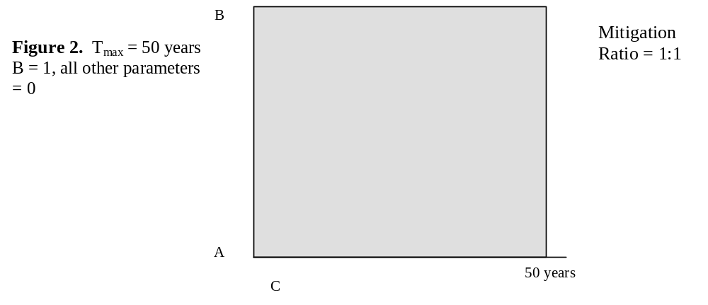

Obviously, the scenario depicted in Figure 2 is highly unlikely which calls into question the widespread use of 1:1 mitigation ratios to score wetland mitigation bank trades. More typical scenarios based on more realistic values of A, B, and C and a few other parameters are described below.

3.2 MRC Version 1: Creation/Restoration as Mitigation
In typical mitigation situations that involve wetland restoration rather than wetland creation, there is already some level of wetland function at the mitigation site (A>0); the restored wetland cannot reach maximum function immediately (C>0), and the function of the mitigation wetland may never equal that of the impacted wetland (B< 100%).

Figures 3, 4 and 5 incrementally add factors that should be reflected in mitigation ratios and show how the shaded area, depicting the amount of mitigation, changes. Figure 3 shows that not giving “credit” for existing wetland function at the mitigation site (area below A) increases the mitigation ratio. Figure 4 shows that if the mitigation project does not achieve full function immediately (C>0) the mitigation ratio is even higher. Figure 5 shows that if the stream of wetland services from the mitigation wetland after mitigation is less than that of the impacted wetland the appropriate mitigation ratio is still higher.

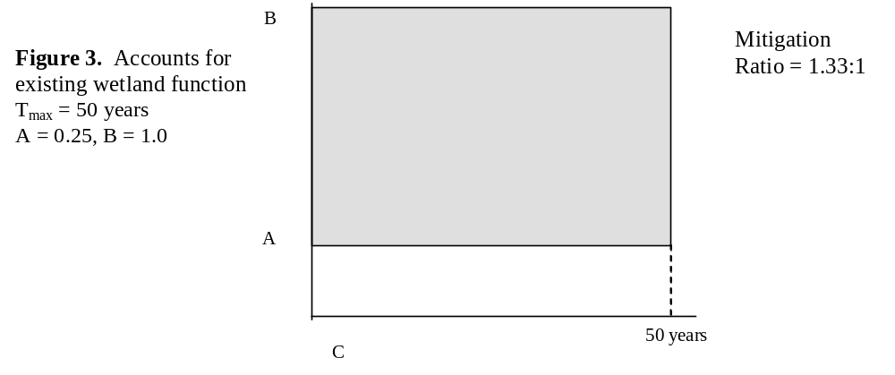
Figure 4. Accounts for time
to achieve function and
existing wetland function
T_{max} = 50 years
A = 0.25, B = 1.0 and C = 10
Mitigation
Ratio = 1.77:1

C
B
50 years
A
B

Figure 5. Accounts for restoration limitations, time to achieve function and existing wetland function
T_{max} = 50 years
A = 0.25, B = 0.75, C = 10
Mitigation
Ratio = 2.66:1

50 years
A
C
B

The A, B, C Framework
The framework outlined in section 3.1 above is relatively simple to apply. Since the shaded area depicts the value provided by an acre of mitigation and the entire rectangle from T₀ to T_{max} depicts the values lost with each acre of the lost wetland, dividing the shaded area by the total area gives the percentage of wetland value compensated with 1:1 mitigation. The inverse of this percentage gives an estimate of the “appropriate” compensation ratio. A 50% loss on an acre-for-acre basis requires a mitigation ratio of 2, compensating 66.6% of wetland value requires a mitigation ratio of 1.5, compensating only 33.3% of wetland value requires a mitigation ratio of 3, and so on.

The percentage loss in wetland value with acre-for-acre mitigation depends directly on the values of A, B, and C. The mitigation ratio, or the number of acres of mitigation required to generate no net loss in the stream of wetland services gained and lost over time, is also based on A, B, and C.

Other Important Factors to Consider
The simple A, B, C framework misses a few important considerations; namely the timing, risk, and landscape context of the mitigation. A more complete version requires adding parameters to account for these three additional considerations, which can be defined as follows:

- risk – that a wetland creation or restoration project will not perform as well as expected. Figure 6 illustrates the effect of considering risk in calculating the mitigation ratio.
- landscape context – to account for differences in landscape context of impacted and mitigation wetlands. Figure 7 demonstrates that enhanced or less-ideal landscape conditions can alter the mitigation ratio in either direction.
- advanced or delayed compensation – the possibility that a mitigation project may be completed and begin providing replacement wetland value either before or after the loss of the original wetland;
Figure 6: Accounts for risk of failure, restoration limits, time to achieve function and existing wetland function
T_{max} = 50 years
A = 0.25, B = 0.75, C = 10, E = 0.15
Mitigation Ratio = 3.43:1

C
50 years
A
B
B_{e}
Value if successful
Risk-corrected value
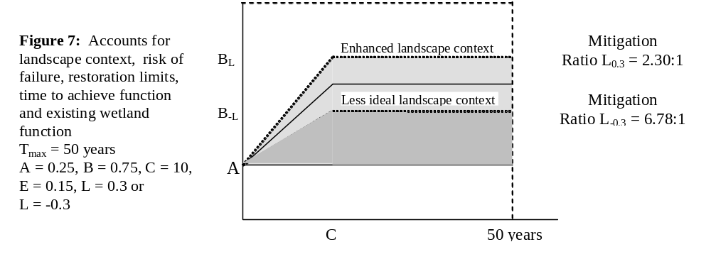

Equation Parameters
The introduction of a few new parameters that consider time, risk that the mitigation will fail, and landscape context into the simple A, B, C framework completes the picture. When these factors are all included in a compensation ratio formula it begins to look like a relatively standard version of the universally used “net present value” formula, which is used to evaluate all types of investments. The problem of monetary valuation is avoided because we are comparing the streams of services from impacted and replacement wetlands in relative terms.

Using the MRC formula, which is presented below, requires the user to estimate or settle upon acceptable values of the following parameters:
A: The level of wetland function provided per acre at the mitigation site prior to the mitigation project, expressed as a percentage of the level of function per acre at the wetland impact site;
B: The maximum level of wetland function each acre of mitigation is expected to attain, if it is successful, expressed as a percentage of the per acre level of function at the wetland impact site;
C: The number of years after construction that the mitigation project is expected to achieve maximum function;
D: The number of years before destruction of the impacted wetland that the mitigation project begins to generate mitigation values (negative values of D represent delayed compensation);
E: The percent likelihood that the mitigation project will fail and provide none of the anticipated benefits (with mitigation failure, wetland values at the mitigation site return to level A);
L: The percent difference in expected wetland values based on differences in landscape context of the mitigation site when compared with the impacted wetland (positive values represent more favorable landscape context at mitigation site);
r : The discount rate used for comparing gains and losses that accrue at different times in terms of their present value (tables provide estimates based on discount rates of 0%, 5%, and 10%);
Tmax: The time horizon used in the analysis (Using the OMB recommended discount rate of r=7%, the impact of gains and losses in wetland values beyond about Tmax = 75 years has a negligible effect on the resulting mitigation ratio)

Under the circumstances described above the discrete time equation that can be used to solve for the appropriate mitigation ratio is as follows:

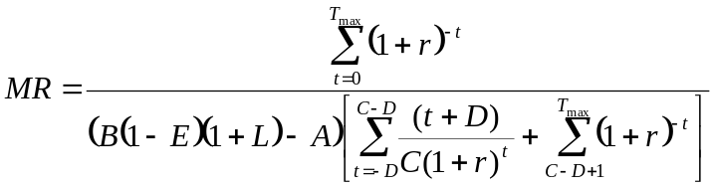
Equation 1

Examples
Table 1 shows some calculated compensation ratios based on the compensation formula in the MRC. The first three cases show the effects on the resulting compensation ratio of delaying or advancing the compensatory mitigation project. The next three examples illustrate how preexisting wetland values at the mitigation site or compensation for the loss of a degraded wetland affect compensation requirements. The third set of examples demonstrates the effect of landscape context on the mitigation ratio. The final set of examples illustrates how the assessment of failure risk can affect the estimated compensation ratio.

The basic characteristics of the mitigation project itself, as reflected in the values of A, B, and C are obviously important in determining the appropriate compensation ratio. The last example shown in Table 1, however, illustrates why advanced mitigation should provide a significant advantage over concurrent mitigation in terms of compensation requirements. Since many mitigation failures can 1) be detected, and 2) be corrected within a year or so of project construction, advanced compensation allows mitigation providers to manage many controllable risk factors and significantly lower the risk of failure. At the same time, advanced mitigation provides replacement wetland values sooner than concurrent mitigation, so there is less discounting of replacement values and more resulting mitigation provided per acre. Combined, these factors result in a substantial advantage for advanced mitigation as compared to concurrent or delayed mitigation in terms of the number of mitigation acres required. Lower compensation ratios for advanced mitigation mean lower mitigation costs, which in many cases could more than offset the cost of committing funds for advanced mitigation or investing in a mitigation bank.

Table 1. Calculated compensation ratios for a variety of hypothetical compensation scenarios, based on a time horizon (Tmax) of 50 years.
 |  |  |  |  |  |  |  | COMPENSATION RATIOS
 | Parameters |  |  |  |  |  |  | Discount Rate
 | A | B | C | D | E | L |  | 0% | 5% | 10%
Concurrent Creation | 0 | 0.7 | 10 | 0 | 0 | 0 |  | 1.6 | 1.9 | 2.3
Advanced Creation | 0 | 0.7 | 10 | 5 | 0 | 0 |  | 1.4 | 1.5 | 1.4
Delayed Creation | 0 | 0.7 | 10 | -5 | 0 | 0 |  | 1.8 | 2.5 | 3.8
Concurrent Restoration | 0.1 | 0.7 | 10 | 0 | 0 | 0 |  | 1.9 | 2.2 | 2.7
Original Wetland Degraded | 0 | 1.4 | 10 | 0 | 0 | 0 |  | 0.8 | 1.0 | 1.2
Concurrent Enhancement | 0.4 | 0.7 | 10 | 0 | 0.2 | 0 |  | 7.0 | 8.3 | 10.2
Concurrent, Enhanced Landscape | 0 | 0.7 | 10 | 0 | 0 | 0.3 |  | 1.2 | 1.5 | 1.8
Concurrent, Less ideal Landscape | 0 | 0.7 | 10 | 0 | 0 | -0.3 |  | 2.3 | 2.7 | 3.3
Difficult Creation | 0 | 0.7 | 10 | 0 | 0.5 | 0 |  | 3.2 | 3.8 | 4.7
Very Difficult Creation | 0 | 0.7 | 10 | 0 | 0.75 | 0 |  | 6.4 | 7.6 | 9.4
Same, Advanced & Risk Adjusted | 0 | 0.7 | 10 | 5 | 0.2 | 0 |  | 1.8 | 1.8 | 1.8

3.3 MRC Version 2: Conservation as Mitigation
In conventional applications of the MRC, mitigation credit is based on the difference between the wetland function at the mitigation site prior to the mitigation (A) and the wetland function at the mitigation site after mitigation (B). In the situation depicted in Figure 8, the value of A is 0.3 and the value of B is 0.8, so the "environmental lift" from the project is 0.5 per acre (B-A = 0.8-0.3 = 0.5). On an acre-acre basis, this mitigation project would get credit for providing half the function lost at the impact site, so the appropriate mitigation ratio would be 2:1.

If we consider instead the case of preservation, where a conservation easement at the same wetland described in Figure 8 is offered as mitigation, there is no “environmental lift” to measure. That is, since no restoration is being undertaken the value of B is equivalent to the value of A (0.3). Note in the initial MRC equation that the situation where B=A, (conservation, but no restoration) would require dividing by a zero.

However, it is possible to use the MRC to estimate mitigation credit for preservation as long as there is at least some risk that the wetland would be developed in the absence of the conservation easement. For example, if the annual risk of development is 5%, then at the end of year 1, in the absence of preservation, there would be a 95% chance that the wetland would remain undeveloped. At the end of year two, the probability that the wetland would still be undeveloped would be 90.25% (95% * 95%), and so on. In the absence of the conservation easement the “expected value” of the wetland function from the site declines over time as the cumulative probability of the site being developed increases. Preventing this loss is the basis for mitigation credits which can be measured by comparing differences between the risk-adjusted expected value of wetland function at the site with and without development risk.
Figure 8.
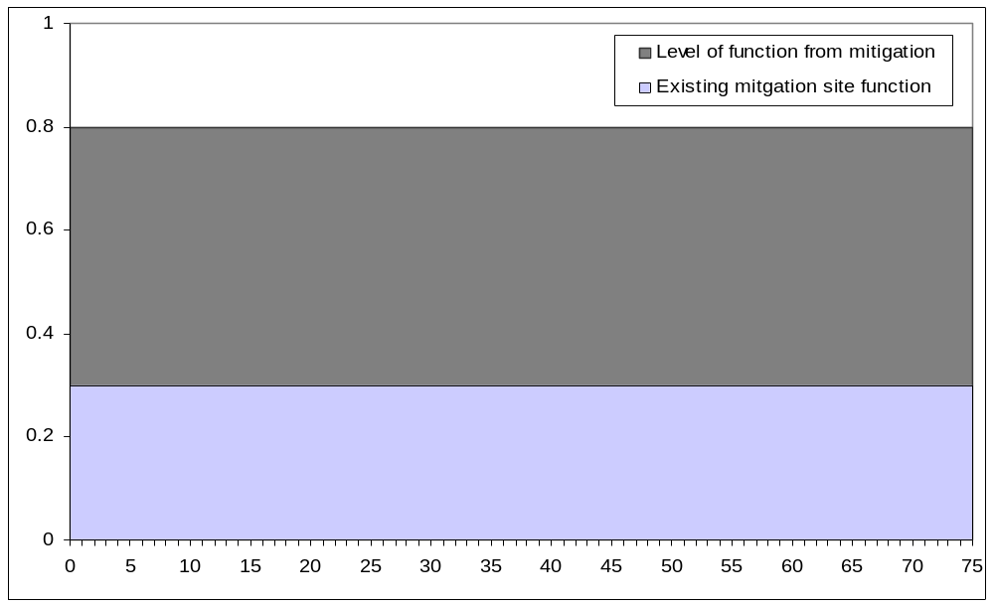

Figure 9.
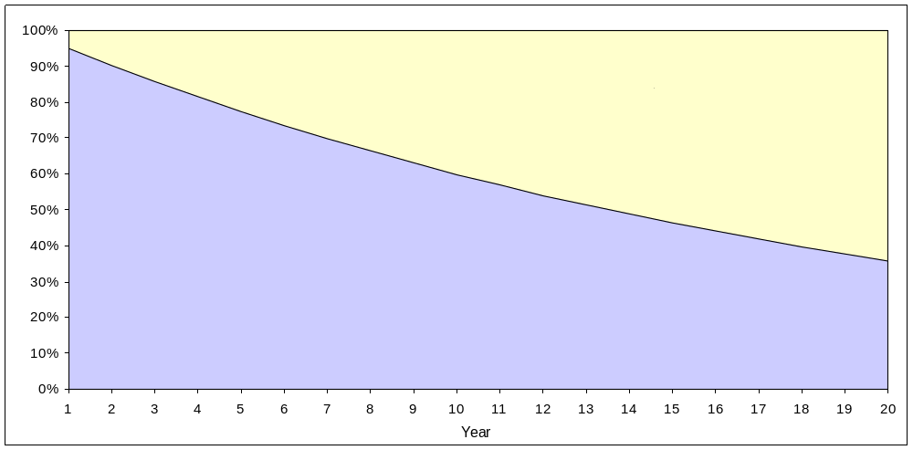

In Figure 9, the area in yellow represents this difference, and can be thought of as the “gain” (actually expected loss of wetland function avoided) associated with the conservation easement. In Figure 9, the wetland site is shown to have a 5% annual risk of development. In this case, therefore, the appropriate mitigation ratio, using a 20 year time horizon would be 2.7:1. If the annual risk of development were 10% or 50% the appropriate mitigation ratio would be 1.7:1 or 1.1:1, respectively.

As in the case with the initial MRC equation additional variables can be factored into the “pure preservation” version of the MRC equation to account for differences in site quality and landscape quality at the impact and mitigation (preservation) site. Using the level of function (A) and the landscape context (L) of the mitigation site in the equation, for example, the appropriate mitigation ratio for pure conservation would be as follows:

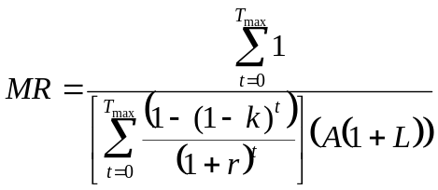

Equation 2

Where:
k = The percent likelihood that the mitigation site, in the absence of the proposed conservation action (e.g., purchase or easement) would be developed in any future year. This is treated as a cumulative distribution function in the equation;
A = existing function at mitigation site as percent of function at impact site
L = landscape context relative to impact site
r = discount rate

Sensitivity Testing
The preservation term is very sensitive to the value of k and to the time horizon used in the analysis. Consider the following values:

Variable | Value
A | 100%
B | 100%
C | 0
D | 0
E | 0
L | 0
k | n%
r | 5%
T_{max} | N

Given different values of k and T_{max}, the calculator generates the following mitigation ratios:

T_{max} = 20 |  |  | T_{max} = 50
k | MR |  | k | MR
1% | 12.8 : 1 |  | 1% | 7.3 : 1
2% | 6.8: 1 |  | 2% | 4.1 : 1
5% | 3.2 : 1 |  | 5% | 2.2 : 1
10% | 2.0 : 1 |  | 10% | 1.6 : 1
25% | 1.4 : 1 |  | 25% | 1.2 : 1
50% | 1.2 : 1 |  | 50% | 1.1 : 1

Figure 10 shows how the value of k affects the probability that the site will remain undeveloped (i.e., survive) over time. The x,y value of any point along the curve is the probability that the mitigation site will be providing habitat function at that time in absence of preservation.

Figure 10.
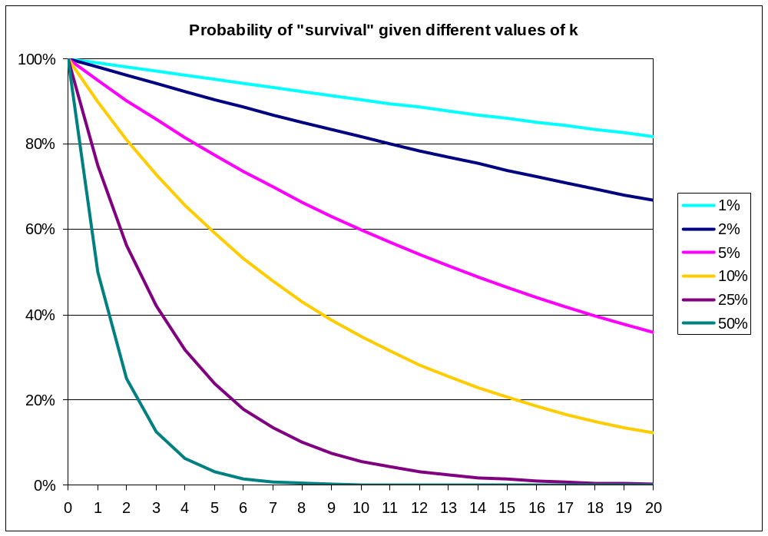

If the value of k is 50%, then there is only a 50% chance that the site would have persisted beyond year 1 without protection. Therefore, the expected value of the wetland function at this site is 0.5, and the owner of a conservation easement on this site (likely a permit seeker) could expect credit for preserving 50% of the function of the site in year 1. At the end of year 2, without protection, there is only a 25% chance that the site would still remain undeveloped (50% * 50%), therefore, the permit seeker could expect credit for ensuring 75% of the function of the site that would have otherwise been lost.

With a development risk as high as 50%, the probability that the site would persist in the absence of preservation drops to a value very close to 0 in just a few years. When that probability approaches 0, the expected “gain” from the preservation (the yellow area in Figure 9 above), is close to 100%. Therefore, if the mitigation site is providing the same level of function as the impact site (i.e., A = 100%), the appropriate mitigation ratio is close to 1:1.

Besides being sensitive to the likelihood and timing of development in the absence of preservation, the mitigation ratio generated by the preservation only version of the MRC is also sensitive to the time horizon (T_{max}) selected for the analysis. From the time the probability of survival drops to a value very close to 0 until T_{max}, the conservation is providing mitigation at a rate close to or equal to 1:1. For example, when the risk of development is 50%, the probability of “survival” in the absence of preservation drops to <1% after year 6; and to near 0 from year 6 until T_{max}. The expected value of the habitat function at the mitigation site during these years, therefore, is near 0, which means that the conservation easement is effectively providing 100% of the function of the site. When T_{max} is large, therefore, the permit seeker accrues a great deal more credit than when the T_{max} represents a more moderate time horizon. For example, when the development risk is 5%, the MR is 2.7:1 when T_{max} = 20 years and 1.6:1 when T_{max} = 50 years. Because development risk over long periods of time is not likely to be a constant, a more conservative approach would be to use shorter time horizons when calculating credit for preservation projects.

Calculating k from Estimated Time of Loss of Site
Users of the revised version of the MRC might find it easier to estimate a time at which the mitigation site is likely to be lost, rather than the annual development risk. For example, based on development rates in nearby areas, the user might estimate, with 95% confidence, that the site is likely to be developed within 20 years if no preservation activity is undertaken. In this case, the basic equation can be used to back-calculate the value of k as follows:
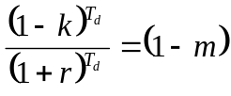
Equation 3

Where:
k = likelihood that the mitigation site will be developed in any given year
T_{d} = the estimated time by which the site will be lost without preservation
m = the confidence the user has in the estimated T_{d}
1-m = the probability the site will “survive” at T_{d}
r = discount rate

Solving this equation for k gives us the following:
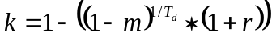
Equation 4

The following table shows different calculated values of k, given the confidence level (m) and estimated T_{d} shown, using a 5% discount rate. For example, if the user believes, with 95% confidence, that the site will be lost in 10 years, the appropriate value of k to plug into the MRC would be 22%. Assuming k is 22% and a T_{max} of 20 years, the appropriate mitigation ratio for preserving this site would be 1.4:1.

Value of k with 5% discount rate
 | Confidence level (m)
T_{d} | 95% | 90% | 85% | 80% | 75%
5 | 42.3% | 33.8% | 28.2% | 23.9% | 20.4%
10 | 22.2% | 16.6% | 13.1% | 10.6% | 8.6%
15 | 14.0% | 9.9% | 7.5% | 5.7% | 4.3%
20 | 9.6% | 6.4% | 4.5% | 3.1% | 2.0%
25 | 6.9% | 4.2% | 2.7% | 1.6% | 0.7%
30 | 5.0% | 2.8% | 1.4% | 0.5% | NA

3.4 MRC Version 3: Combined Creation/Restoration & Conservation
In some cases, preservation may be combined with restoration activity at a site to provide a basis for considering mitigation using both criteria. A situation may exist, for example, where preservation and restoration of a stream are accomplished through land acquisition and dam removal. In this case, the pure preservation equation described above can simply be added to the standard MRC equation as follows:
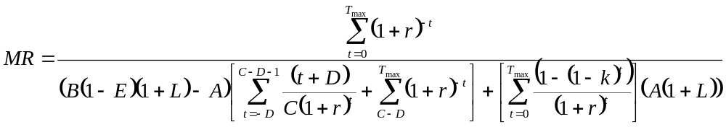
Original denominator/ Creation or restoration term
Preservation term

Equation 5

This equation is just the original MRC equation with the preservation term added to the denominator. In essence, the numerator in the equation measures the wetland services that are lost on a per acre basis at the impact site and the denominator measures what is gained at the mitigation site. If what is gained is only creation or restoration the factor shown on the left hand side of the denominator is used. If what is gained is only preservation the factor shown on the right-hand side of the denominator is used. If what is gained is both restoration (or creation) and preservation, then the equation above, which includes both factors, is used.

As an example of this application, assume the following values for the variables associated with the land acquisition/dam removal project described above:

Variable | Value
A | 50%
B | 75%
C | 0
D | 0
E | 0
L | 0
k | 5%
r | 5%
T_{max} | 20

This set of values indicates that the existing stream is providing 50% of the function of the impacted stream, but with removal of the dam, the function will increase to 75% of the impacted stream. Additionally, the 5% development risk will be removed when the land is acquired. Using the equation above, at a 5% discount rate, the mitigation ratio for this project would be 2.45:1.

4. Recommended Application Methods

4.1 Selecting the Equation
Equation 1 should be used to estimate the appropriate mitigation ratio when the proposed mitigation involves wetland creation, restoration, or enhancement. Wetland creation, in effect, is a special case of wetland restoration where there is no level of wetland function prior to the restoration project (A=0). A fully degraded wetland being considered for restoration may also register an initial, pre-restoration value of A=0. Differences in the appropriate mitigation ratio in each case will depend on the values assigned to other parameters, such as B, the maximum level of wetland function expected with the project and E, the likelihood that the project will fail.

Equation 2 should be used to estimate the appropriate mitigation ratio when the proposed mitigation involves wetland conservation (preservation) only. The emphasis here is on the likelihood and expected timing of the loss or degradation of the mitigation wetland in the absence of the proposed purchase or easement.

Equation 5 should be used to estimate the appropriate mitigation ratio when the proposed mitigation involves both conservation (preservation) of wetland areas and wetland creation, restoration or enhancement. This equation is a combination of Equations 1 and 2, and it reduces the acres of wetland conservation required to provide adequate mitigation as the quantity or quality of proposed wetland creation or restoration increases, and vice versa.

The equation presented in Appendix E should be used in the unusual situation referred to as “self-mitigation” where the development project itself provides partial mitigation for the wetland impact it is causing. This situation arose, for example, in a case in Alaska where a fish hatchery intended to enhance natural fish stocks and generate fishery-related benefits was proposed for construction on a wetland area that was important primarily because of its fishery related benefits. Except in the rare situation where “self-mitigation” fully offsets wetland impact losses, this equation will need to be used in combination with Equation 1, 2, or 5.

4.2 Estimating Parameters
The most direct way to estimate the relative value of wetlands is to start with conventional wetland functional capacity indices, such as those developed through Hydrogeomorphic Method (HGM) or Wetlands Rapid Assessment Process (WRAP), and extend them to consider the effects of landscape context on expected level of function (e.g., rate of functional capacity utilization) and related services, values, and risk. The recommended method is based on three sets of wetland site capacity adjustment indices, including:

- Functional Capacity Utilization Index – Indicators of landscape conditions that determine how much of the functional capacity of the site is likely to be used.
- Service Value Index – Indicators of landscape conditions that limit or enhance the level of services expected per unit of function (output per unit capacity) or the expected value per unit service (value per unit output).
- Service Risk Index – Indicators of the likelihood of future disruptions in service flows that affect the value of expected wetland services. These are related to the exposure and vulnerability of the site or other critical landscape features to such threats as floods, droughts, fire, disease, infestations, water diversion, pollution, and industrial development.

4.3 Interpreting and Using Results
The mitigation ratios estimated using the standardized formula developed in this paper can be interpreted to result in “no net loss” of the expected stream of risk-adjusted wetland services. They are based on the universal “net present value” formula that is applied routinely to compare all types of income-generating and benefit producing assets.

This paper recommends the use of this standardized formula for developing defensible wetland mitigation ratios that should withstand technical and legal challenges. As a practical matter, however, it can be presumed that for the foreseeable future wetland mitigation ratios in the U.S. will continue to be based on some combination of ad hoc negotiations or on the basis of pre-negotiated regulator-approved “look up” tables. The most valuable application of the approach developed here in the near-term, therefore, may be to influence the mitigation ratios that are developed in these ways and to challenge them when they are clearly inadequate.

4.4 Conclusions and Recommendations
The framework and formula described above and in the accompanying spreadsheet program are based on generally accepted economic concepts. However, the parameters used to estimate compensation ratios related to any particular project (e.g., A, B, and C) are based on wetland science, or at least the judgment of wetland scientists. It is useful to note that employing the formula allows mitigation providers the option of providing more mitigation by investing at either the intensive or extensive margin. For example, if the mitigation provider spends more per acre to increase the quality per acre of mitigation provided (e.g., higher B, lower C, or both), the mitigation ratio that reflects the number of acres required will decline. If the mitigation provider spends more on land (acres) and less on restoration efforts ($ per acre), the mitigation value per unit area will be lower and the required mitigation ratio (number of acres) will increase.

The proposed formula can serve several purposes. It can help prevent wetland mitigation trades that result in losses of wetland values and impose risks on the general public. It can make mitigation requirements more predictable and consistent for permit seekers. And, it can help mitigation providers understand the payoff from investing in wetland mitigation credits at the intensive margin (more $ per acre) or at the extensive margin (more acres). Finally, the formula also allows the level of wetland mitigation to be based on science and economics, not politics, and generates compensation ratios that will withstand most technical and legal challenges.

References
Bartoldus, C.C. 1999. A comprehensive review of wetland assessment procedures: A guide for wetland practitioners. Environmental Concern, Inc., St. Michaels, MD. 196 pp.

Brown, P.H. and C.L. Lant. 1999. The effect of mitigation banking on the achievement of no-net-loss. Environmental Management 23: 333-345.

Environmental Law Institute. 2002. Banks and Fees: The Status of Off-Site Wetland Mitigation in the United States. Environmental Law Institute.

King, D.M. and C.B. Bohlen. 1994. Compensation ratios for wetland mitigation: Guidelines and tables for applying the methodology. In: Wetland Mitigation: A Framework for Determining Compensation Ratios. A report prepared for the US EPA, Office of Policy Analysis, Washington, DC.

King, D.M. 1997. Valuing wetlands for watershed planning. National Wetlands Newsletter 19(3): 5-10.

King, D.M. and H.W. Herbert. 1997. The Fungibility of Wetlands. National Wetlands Newsletter. 19)5):10-13.

Memorandum of Agreement Between the Environmental Protection Agency and the Department of the Army Concerning the Determination of Mitigation Under the Clean Water Act 404(b)(1) Guidelines, 55 FR 9210-01, 1990.

National Research Council. 2001. Compensating for Wetland Losses Under the Clean Water Act. National Academy Press, Washington D.C.

Office of Program Policy Analysis and Government Accountability. 2001. Cumulative Impact Consideration in Environmental Resource Permitting. Department of Environmental Protection and Florida’s Water Management Districts Report No. 01-40.

Robb, J.T. 2002. Assessing wetland compensatory mitigation sites to aid in establishing mitigation ratios. Wetlands 22: 435-440.

Ruhl, J.B. and J. Gregg. 2001. Integrating Ecosystem Services into Environmental Law: A Case Study of Wetlands Mitigation Banking. Stanford Environmental Law Journal 20:2: 365-392.

Appendix A Wetland mitigation ratio calculator

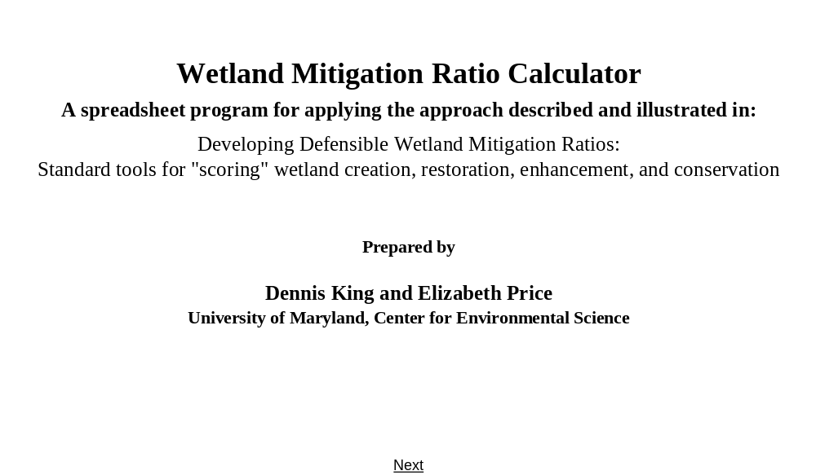

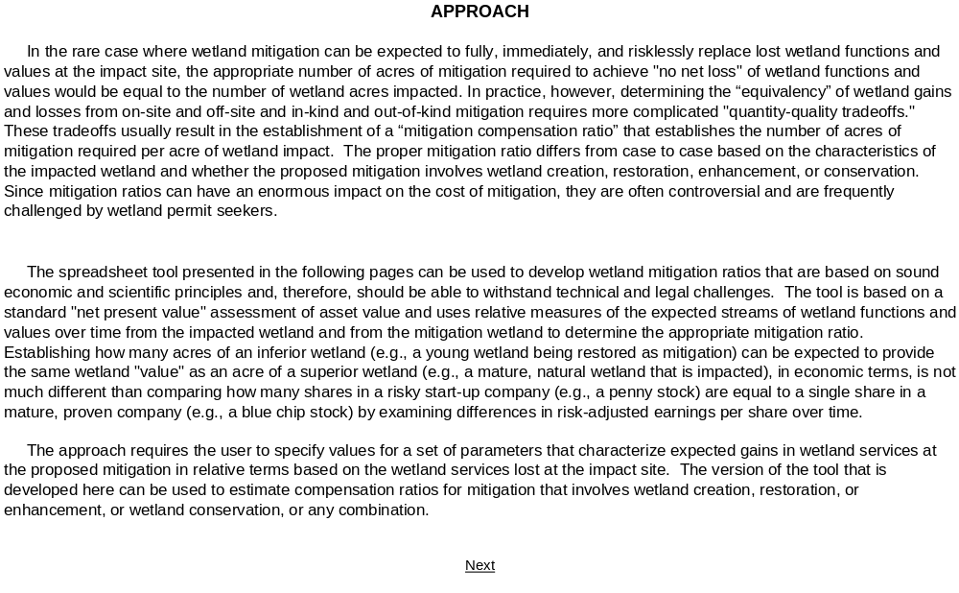
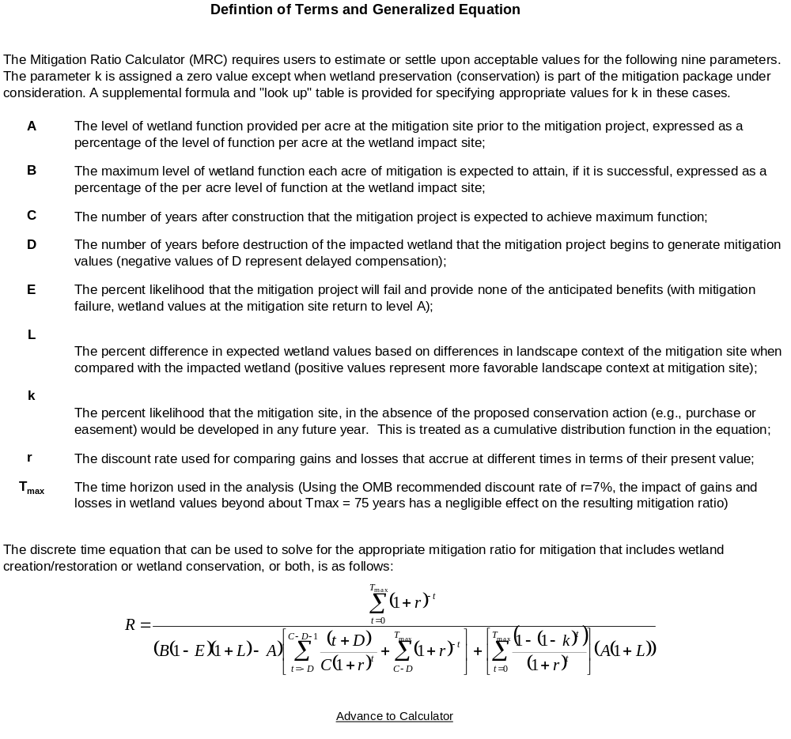
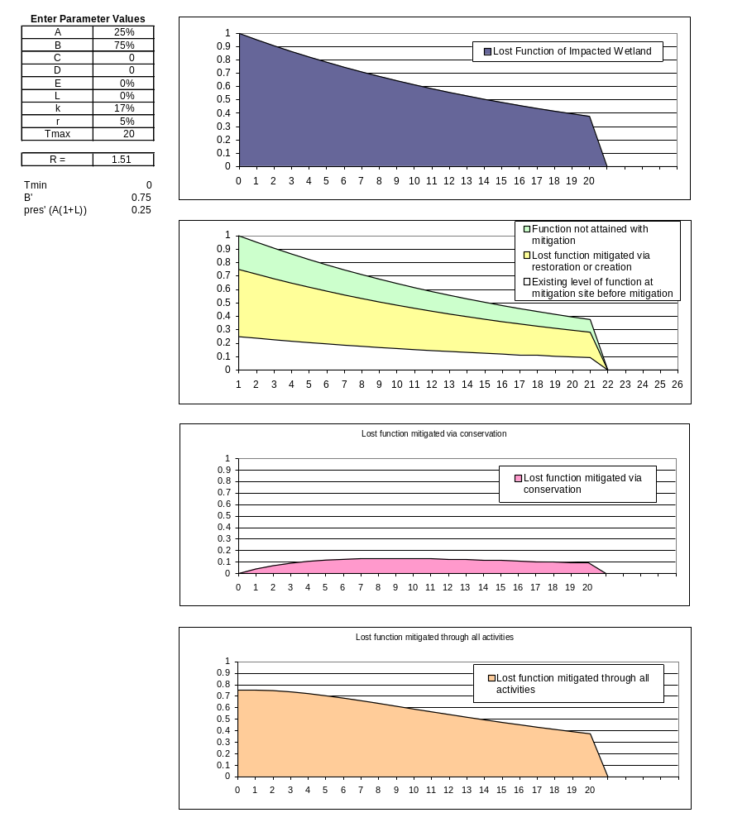
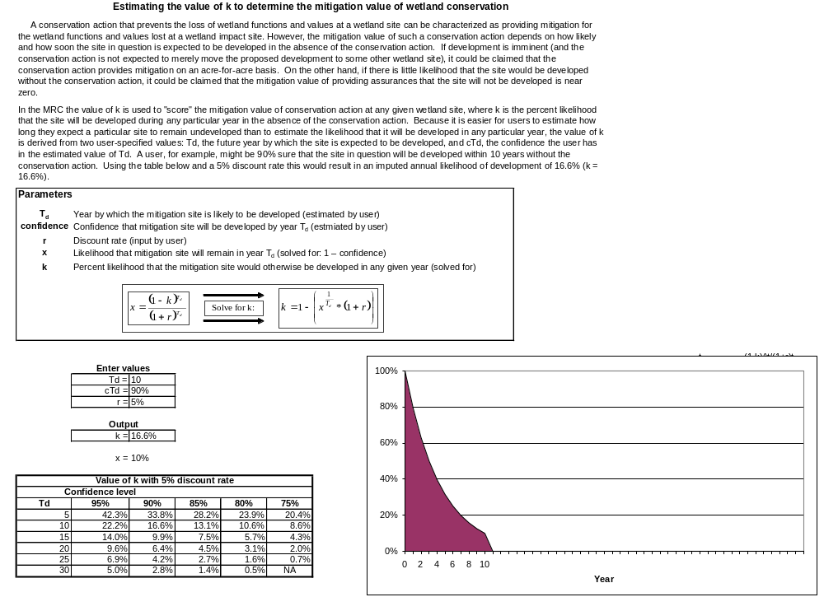

Appendix B Potential Wetland Assessment Methods

 | Name | Acronym | Reference
1 | Alberta Lentic | Alberta Lentic | Alberta Riparian Habitat Management Society 2003a, b, 2004a, b
2 | Alberta Lotic | Alberta Lotic | Alberta Riparian Habitat Management Society 2003c, 2004c, d
3 | Amphibian IBI | Amphibian IBI | Micacchion 2002
4 | Avian Richness Evaluation Method | AREM | Adamus 1993a, b
5 | Bay Area Watershed Science Approach | WSA | Watershed Science Team 1998
6 | Bird Community Index | BCI | O’Connell et al. 1998, 2000
7 | California Rapid Assessment Method | CRAM | Collins et al. 2004
8 | Connecticut Method | Connecticut Method | Ammann et al. 1986
9 | Coral Reef Assessment and Monitoring Program | CRAMP | Jokiel and Friedlander 2004
10 | Delaware Method | DE Method | Jacobs 2003
11 | Eeelgrass | Eelgrass | Short et al. 2000
12 | Evaluation for Planned Wetlands | EPW | Bartoldus et al. 1994
13 | Floristic Quality Assessment Index | FQAI | Andreas et al. 2004, Bernthal 2003, Herman et al. 2001, Lopez and Fennessy 2002, Mushet et al. 2002, NGPFQP 2001
14 | Habitat Assessment Technique | HAT | Cable et al. 1989
15 | Habitat Evaluation Procedure | HEP | USFWS 1980, 1981
16 | Hollands-Magee Method | Hollands-Magee Method | Hollands and Magee 1985
17 | Hydrogeomorphic Approach | HGM Approach | NRCS et al. 1995, Smith 1993, Smith et al. 1995, Whited 1997
17 | Hydrogeomorphic Approach | HGM Approach - AR | AR Multi-Agency Wetland Planning Team 2001
17 | Hydrogeomorphic Approach | HGM Approach – Deciduous Wetland Flats | Rheinhardt et al. 1995, Rheinhardt and Brinson 1997
17 | Hydrogeomorphic Approach | HGM Approach – Estuarine Fringe OR | Adamus 2004
17 | Hydrogeomorphic Approach | HGM Approach – Guidebook AK | Hall et al. 2003
17 | Hydrogeomorphic Approach | HGM Approach – PA | Wardrop et al. 1998
17 | Hydrogeomorphic Approach | HGM Approach – Prairie Potholes | Whited et al. 2003
17 | Hydrogeomorphic Approach | HGM Approach – Riverine Guidebook | Brinson et al. 1995
17 | Hydrogeomorphic Approach | HGM Approach – Riverine impounding Willamette Valley, OR | Adamus 2001, Adamus and Field 2001
17 | Hydrogeomorphic Approach | HGM Approach – Riverine Coastal Plain, Chesapeake Bay | USACE 1995a
17 | Hydrogeomorphic Approach | HGM Approach – Riverine Western KY | Ainslie et al. 1999
17 | Hydrogeomorphic Approach | HGM Approach – Riverine/slope AK | Powell et al. 2003
17 | Hydrogeomorphic Approach | HGM Approach – Tidal Fringe Guidebook | Shafer and Yozzo 1998
18 | Index of Biotic Integrity | IBI | Karr 1981, 1987, 1990
19 | Indicator Value Assessment | IVA | Hruby 1995
20 | Larson-Golet Method | Larson-Golet Method | Golet 1976, Golet and Davis 1982, Heeley and Motts 1976, Larson 1976, Wencek 1986
21 | Maryland Department of the Environment Method | MDE Method | East 1995, Taylor et al. 1997
22 | Methods for Assessing Wetland Functions | MAWF | Hruby and Granger 1996, Hruby et al.1997, 1999a, b, 2000a, b, 2004, WA State Dept Ecology 2002
23 | Minnesota Routine Assessment Method | MIN RAM | MBWSR 2004
24 | Montana Wetland Assessment Method | MT Form | Berglund 1999
25 | New Hampshire Method | NH Method | Ammann and Stone 1991
26 | New Jersey Freshwater Wetland Mitigation | NJ Freshwater Wetland Mitigation | Balzano et al. 2002
27 | North Carolina Coastal Region Evaluation of Wetland Significance | NC-CREWS | Sutter et al. 1999
28 | North Carolina Guidance for Rating Values of Wetlands | NC Method | NCDEHNR 1995
29 | Ohio Rapid Assessment Method for Wetlands | ORAM | Mack 2001
30 | Oregon Method | Oregon Method | Roth et al. 1993, 1996
31 | Oregon Watershed Assessment Manual | OR Watershed Assessment Manual | OR Watershed Enhancement Board 1999
32 | Oyster | Oyster | Coen and Luckenbach 2000
33 | Pennsylvania Habitat Evaluation Procedure | PAM HEP | Palmer et al. 1985, USFWS 1980
34 | Process for assessing proper functioning condition | PFC | Clemmer 1994, Gebhardt et al. 1990, Leonard et al. 1992, Lewis et al. 2003, Myers 1989, Prichard 1993, Prichard et al. 1993, 1996, Sada et al. 2001
35 | Process for assessing proper functioning condition | PFC – Lentic | Prichard et al. 1998b, 1999
36 | Process for assessing proper functioning condition | PFC – Lotic | Prichard et al. 1998a
37 | Salt marsh health | Salt marsh health | Pennings et al. 2002
38 | Savannah District SOP | Savannah District SOP | USACE Savannah District. 2003
39 | Synoptic Approach for Wetlands | Synoptic Approach | Abbruzzese et al 1990a, b, Abbruzzese and Leibowitz 1997, Hyman and Leibowitz 2000, Leibowitz et al. 1992, McAllister et al. 2000, Schweiger et al. 2002, Vellidis et al. 2003
40 | TNC - Integrity Assessment and Ecological Models | TNC - Integrity Assessment | TNC 2003, 2004a, b
41 | TNRCC Stream Habitat Assessment Procedure | TNRCC Stream Habitat Assessment Procedure | TNRCC 1999
42 | Transport Suitability Index | TSI | Short and Davis 1999
43 | Vegetation Index of Biotic Integrity | VIBI | Mack et al. 2000
44 | VIMS Method | VIMS Method | Bradshaw 1991
45 | WA State Wetland Rating System (Western) | WA State Wetland Rating System | WA State Dept Ecology 1993
46 | Water Quality Index | WQI | Lodge et al. 1995
47 | Wetland Evaluation Technique | WET2 | Adamus et al. 1987, 1991
48 | Wetland Functions and Values | Descriptive Approach | USACE 1995b
49 | Wetland Habitat Indicators for Nongame Species | WEThings | Whitlock et al. 1994a, b
50 | Wetland Habitat Indicators for Nongame Species | WEThings - Birds | Crowley et al. 1994, Crowley 1997
51 | Wetland Rapid Assessment Methodology | WRAP | Miller and Gunsalus 1997
52 | Wetland Value Assessment Methodology | WVA | EWG 2002
53 | Wildlife Habitat Appraisal Procedure | WHAP | TPWD 1991
54 | Wisconsin Rapid Assessment Methodology | WI RAM | WDNR 2001

BIBLIOGRAPHY OF ASSESSMENT METHODS

Abbruzzese, B., S. G. Leibowitz, and R. Sumner. 1990a. Application of the Synoptic Approach to Wetland Designation: A Case Study in Washington U.S. EPA Environmental Research Lab, Corvallis, OR.

Abbruzzese, B., S. G. Leibowitz, and R. Sumner. 1990b. Application of the Synoptic Approach to Wetland Designation: A Case Study in Louisiana U.S. EPA Environmental Research Lab, Corvallis, OR.

Abbruzzese, B., and S.G. Leibowitz. 1997. A synoptic approach for assessing cumulative impacts to wetlands. Environmental Management 21(3): 457-475.

Adamus, P.R., E.J. Clairain, R.D. Smith and R.E. Young. 1987. Wetland Evaluation Technique. Volume II: Methodology U.S. Army Corps of Engineers, Waterways Experiment Station, Vicksburg MS.

Adamus, P.R., L.T. Stockwell, E.J. Clairain, Jr., M.E. Morrow, L.P. Ronzas, and R.D. Smith. 1991. Wetland evaluation technique (WET) Volume I: Literature review and evaluation rationale. Technical Report WRP-DE-Z. U.S. Army Corps of Engineers. National Technical Information Service. Springfield, VA.

Adamus, P.R. 1993a. Irrigated wetlands of the Colorado plateau: information synthesis and habitat evaluation method. EPA/600/R-93/071. Environmental Research Laboratory, U.S. Environmental Protection Agency, Corvallis, OR.

Adamus, P.R. 1993b. User's manual: avian richness evaluation method (AREM) for lowland wetlands of the Colorado Plateau. EPA/600/R-93/240. Environmental Research Laboratory, U.S. Environmental Protection Agency, Corvallis, OR. NTIS No. PB93186260.

Adamus, P.R. 2001. Guidebook for hydrogeomorphic (HGM)-based assessment of Oregon wetland and riparian sites. I. Willamette Valley ecoregion, riverine impounding and slope/flats subclasses. Volume IB: Assessment methods. Oregon Division of State Lands, Salem, OR.

Adamus, P.R., and D. Field. 2001. Guidebook for hydrogeomorphic (HGM)-based assessment of Oregon wetland and riparian sites. I. Willamette Valley ecoregion, riverine impounding and slope/flats subclasses. Volume IIA: Assessment methods. Oregon Division of State Lands, Salem, OR.

Adamus, P.R. 2004. (in preparation). Guidebook for HGM-based assessment of Oregon wetlands: I. estuarine fringe wetlands. Volume IA: Assessment methods. Oregon Department of State Lands, Coos Watershed Association, and U.S. Environmental Protection Agency.

Ainslie, W.B., Smith, R.D., Pruitt, B.A., Roberts, T.H., Sparks, E.J., West, L., Godshalk, G.L., and Miller, M.V. 1999. A Regional Guidebook for Assessing the Functions of Low Gradient, Riverine Wetlands in Western Kentucky, Technical Report WRP-DE-17, U.S. Army Engineer Waterways Experiment Station, Vicksburg, MS.

Alberta Riparian Habitat Management Society. 2003a. Bitter Root Restoration, Inc. lentic proper functioning condition (PFC) checklist: user manual and form. Retrieved July 23, 2004 from http://www.bitterrootrestoration.com/index.html

Alberta Riparian Habitat Management Society. 2003b. Alberta lentic wetland health assessment (derived from the Alberta lentic wetland inventory form): user manual and form. Retrieved July 23, 2004 from http://www.bitterrootrestoration.com/index.html

Alberta Riparian Habitat Management Society. 2003c. Alberta lotic wetland health assessment (derived from the Alberta lotic wetland inventory): user manual and form. Retrieved July 23, 2004 from http://www.bitterootrestoration.com/index.html

Alberta Riparian Habitat Management Society. 2004a. Alberta lentic wetland health assessment (survey): users manual and form. Retrieved June 22, 2004 from http://www.cowsandfish.org/health.html

Alberta Riparian Habitat Management Society. 2004b. Alberta lentic wetland inventory: user manual and form. Retrieved July 23, 2004 from http://www.bitterrootrestoration.com/index.html

Alberta Riparian Habitat Management Society. 2004c. Alberta lotic inventory users manual and form. Retrieved July 19, 2004 from http://www.cowsandfish.org/health

Alberta Riparian Habitat Management Society. 2004d. Alberta lotic wetland inventory: user manual and form. Retrieved July 23, 2004 from http://www.bitterrootrestoration.com/index.html

Ammann, A.P., R.W. Frazen, and J.L. Johnson. 1986. Method for the Evaluation of Inland Wetlands in Connecticut. DEP Bulletin No. 9. Connecticut Department of Environmental Protection, Hartford, CT.

Ammann, A.P. and A. Lindley Stone. 1991. Method for the Comparative Evaluation of Nontidal Wetlands in New Hampshire. NHDES-WRD-1991-3. New Hampshire Department of Environmental Services, Concord, NH.

Andreas, B.K., J.J. Mack, and J.S. McCormac. 2004. Floristic quality assessment index (FQAI) for vascular plants and mosses for the state of Ohio. Division of Surface Water, Ohio Environmental Protection Agency, Columbus, OH.

Arkansas Multi-Agency Wetland Planning Team. 2001. Arkansas wetland planning regions. Retrieved June 4, 2004 from http://www.mawpt.org/wetlands/classification/project.asp
Balzano, S., A. Ertman, L. Brancheau, W. Smejkal, M. Kaplan, and D. Fanz. 2002. Creating indicators of wetland status (quantity and quality): freshwater wetland mitigation in New Jersey. Trenton, N.J.

Bartoldus, C.C., E.W. Garbisch, and M.L. Kraus. 1994. Evaluation for Planned Wetlands (EPW). Environmental Concern Inc., St. Michaels, MD. 327 pp. and appendices.

Berglund, J. 1999. Montana wetland assessment method. Montana Department of Transportation and Morrison-Maierle, Inc., Helena, MT.

Bernthal, T.W. 2003. Development of a floristic quality assessment methodology for Wisconsin. Wisconsin Department of Natural Resources, Madison, WI.

Bradshaw, J.G. 1991. A Technique for the Functional Assessment of Nontidal Wetlands in the Coastal Plain of Virginia. Special Report No. 315 in Applied Marine Science and Ocean Engineering. Virginia Institute of Marine Science, College of William and Mary, Gloucester Point, VA.

Brinson, M.M, F.H. Hauer, L.C. Lee, W.L. Nutter, R.D. Rheinhardt, R.D. Smith, and D. Whigham. 1995. A guidebook for application of hydrogeomorphic assessments to riverine wetlands. Technical Report WRP-DE-11. Waterways Experiment Station, U.S. Army Corps of Engineers, Vicksburg, MS.

Cable, T. B, V. Brack Jr., and V.R. Holms. 1989. Simplified Method for Wetland Habitat Assessment. Environmental Management, 13: (2) 207-213.

Clemmer, P. 1994. Riparian area management: the use of aerial photography to manage riparian-wetland areas. Technical Reference 1737-10. Bureau of Land Management, U.S. Department of the Interior, Denver, CO.

Coen, L.D., and M.W. Luckenbach. 2000. Developing success criteria and goals for evaluating oyster reef restoration: ecological function or resource exploitation? Ecological Engineering 15(2000): 323-343.

Collins, J.S., E. Stein, and M. Sutula. 2004. (Draft). California rapid assessment method for wetlands, version 2.0. Retrieved February 1, 2004 from San Francisco Bay area wetlands regional monitoring program web site http://www.wrmp.org/index.html

Crowley, S., C. Welsh, P. Cavanagh, and C. Griffin. 1994. WEThings - birds: habitat assessment procedures for wetland-dependent birds in New England. Volume I: Model descriptions. Department of Forestry and Wildlife Management, University of Massachusetts, Amherst, MA.

Crowley, S., Griffin, C, C. Welsh, P. Cavanagh, and J.A. Medina. 1997. WEThings - Birds: habitat assessment procedures for wetland-dependent birds in New England. Volume II: Computer program manual. Department of Forestry and Wildlife Management, University of Massachusetts, Amherst, MA.

East, F. 1995. A method for the assessment of wetland function. Maryland Department of the Environment, Northborough, MA.

Environmental Work Group. 2002. Coastal wetlands planning, protection and restoration act, wetland value assessment methodology, emergent marsh community models. U.S. Fish and Wildlife Service, Lafayette, LA.

Gebhardt, K., S. Leonard, G. Staidl, and D. Prichard. 1990. Riparian area management: riparian and wetland classification review. Technical Reference 1737-5. Bureau of Land Management, U.S. Department of the Interior, Denver, CO.

Golet, F.C. 1976. Wildlife Wetland Evaluation Model. Pages 13-34 In Larson, J.S. (ed). Models for Assessment of Freshwater Wetlands, Publication No. 32, Water Resources Research center, University of Massachusetts, Amherst, MA.

Golet, F.C., and A.F. Davis. 1982. Inventory and habitat evaluation of the wetlands of Richmond, Rhode Island. Occasional Papers in Environmental Science No. 1. College of Resource Development, University of Rhode Island, Kingston. 48 pp.

Hall, J., J. Powell, S. Carrick, T. Rockwell, G.G. Hollands, T. Walter, and J. White. 2003. Wetland functional assessment guidebook, Operational draft guidebook for assessing the functions of slope/flat wetland complexes in the Cook Inlet Basin Ecoregion Alaska, using the HGM Approach. State of Alaska Department of Environmental Conservation/ US Army Corps of Engineers Waterways Experiment Station Technical Report: WRP-DE-___.

Heeley, R.W. and W.S. Motts. 1976. A model for the evaluation of ground-water resources associated with wetlands. Pages 52-65 In Larson, J.S. (ed). Models for Assessment of Freshwater Wetlands, Publication No. 32, Water Resources Research center, University.

Herman, K.D., L.A. Masters., M.R. Penskar, A.A. Reznicek, G.S. Wilhelm, W.W. Brodovich, and K.P. Gardiner. 2001. Floristic quality assessment with wetland categories and examples of computer applications for the State of Michigan, Revised, Second Edition. Michigan Department of Natural Resources, Gladstone, MI.

Hollands, G.G., and D.W. Magee. 1985. A Method for Assessing the Functions of Wetlands. Pages 108-118 In J. Kusler and P. Riexinger (eds.), Proceedings of the National Wetland Assessment Symposium, Association of Wetland Managers, Berne, NY.

Hruby, T., W. E. Cesanek and K. E. Miller. 1995. Estimating Relative Wetland Values for Regional Planning. Wetlands, 15: (2) 93-107.

Hruby, T. and T. Granger. 1996. (Draft). An approach to developing methods to assess the performance of Washington's wetlands. Publication No. 96-110. Washington State Department of Ecology Shorelands and Water Resources Program, Olympia, WA.

Hruby, T., K. Brunner, S.S. Cooke, K. Dublanica, R.A. Gersib, T. Granger, L. Reinelt, K. Richter, S. Sheldon, A. Wald, and F. Weinmann. 1997. Draft methods to assess riverine and depressional wetlands and the lowlands of Western Washington. Publication # 97-33. Washington State Department of Ecology, Olympia, WA.

Hruby, T., T. Granger, K. Brunner, S.S. Cooke, K. Dublanica, R.A. Gersib, L. Reinelt, K. Richter, D. Sheldon, F. Teachout, A. Wald, and F. Weinmann. 1999a. Methods for assessing wetland functions. Volume I: Riverine and depressional wetlands and the lowlands of Western Washington, part I: assessment methods. Publication # 99-115. Washington State Department of Ecology, Olympia, WA.

Hruby, T., T. Granger, and E. Teachout. 1999b. Methods for assessing wetland functions. Volume I: Riverine and depressional wetlands in lowlands of Western Washington, part 2: procedures for collecting data. Publication #99-116. Washington State Department of Ecology, Olympia, WA.

Hruby, T., S. Stanley, T. Granger, T. Duebendorfer, R. Friesz, B. Lang, B. Leonard, K. March, and A. Wald. 2000a. Methods for assessing wetland functions. Volume II: Depressional wetlands in the Columbia Basin of Eastern Washington, part I: assessment methods. Publication #00-06-47. Washington State Department of Ecology, Olympia, WA.

Hruby, T., S. Stanley, T. Granger, T. Duebendorfer, R. Friesz, B. Lang, B. Leonard, K. March, and A. Wald. 2000b. Methods for assessing wetland functions. Volume II: Depressional wetlands in the Columbia Basin of Eastern Washington, part 2: procedures for collecting data. Publication #00-06-48. Washington State Department of Ecology, Olympia, WA.

Hruby, T. 2004. (Draft). Washington State wetlands rating system: Western Washington. Publication #04-06-014. Washington State Department of Ecology, Olympia, WA.

Hyman, J.B., and S.G. Leibowitz. 2000. A general framework for prioritizing land units for ecological protection and restoration. Environmental Management 25(1): 23-35.

Jacobs, A.D. 2003. (Draft). Delaware rapid assessment procedure. Delaware Department of Natural Resources and Environmental Control, Dover, DE.

Jokiel, P.L., and A. Friedlander. 2004. Hawaii coral reef assessment and monitoring program (CRAMP). Retrieved June 24, 2004 from http://cramp.wcc.hawaii.edu

Karr, J. R. 1981. Assessment of Biotic Integrity Using Fish Communities. Fisheries, 6: (6) 21-27.

Karr, J. R. 1987. Biological Monitoring and Environmental Assessment: a Conceptual Framework. Environmental Management, 11: (2) 249-256.

Karr, J. R. 1990. Biological integrity and the goal of environmental legislation: Lessons for conservation biology. Conservation Biology, 4: (3) 244-250.

Larson, J.S. (ed). 1976. Models for Assessment of Freshwater Wetlands, Publication No. 32, Water Resources Research center, University of Massachusetts, Amherst, MA.

Leibowitz, S.G., B. Abbruzzese, P.R. Adamus, L.E. Hughes, and J.T. Irish. 1992. A synoptic approach to cumulative impact assessment. A Proposed Methodology. U.S. Environmental Protection Agency, Corvallis, OR.

Leonard, S., G. Staidl, J. Fogg, K., Gebhardt, W. Hagenbuck, and D. Prichard. 1992. Riparian area management: procedures for ecological site inventory - with special reference to riparian-wetland sites. Technical Reference 1737-7. Bureau of Land Management, U.S. Department of the Interior, Denver, CO.

Lewis, L., L. Clark, T. Subirge, R. Krapf, L. Townsend, M. Manning, B. Ypsilantis, and J. Staats. 2003. Riparian area management: riparian-wetland soils. Technical Reference 1737-19. Bureau of Land Management, U.S. Department of the Interior, Denver, CO.

Lodge, T.E., H.O. Hillestad, S.W. Carney, and R.B. Darling. 1995. Wetland Quality Index (WQI): A method for determining compensatory mitigation requirements for ecologically impacted wetlands. Paper presented at the American Society of Civil Engineers South

Lopez, R.D., and M.S. Fennessy. 2002. Testing the floristic quality assessment index as an indicator of wetland condition. Ecological Applications 12(2): 487-497.

Mack, J.J., M. Micacchion, L.P. Augusta, G.R. Sablak. 2000. Vegetation indices of biotic integrity (VIBI) for wetlands and calibration of the Ohio rapid assessment method for wetlands, version 5.0. Interim Report to the U.S. Environmental Protection Agency Grant No. CD985875. Wetland Ecology Unit, Ohio Environmental Protection Agency, Columbus, OH.

Mack, J.J. 2001. Ohio rapid assessment method for wetlands, manual for using version 5.0. Ohio EPA Technical Bulletin Wetland/2001-1-1. Division of Surface Water, Ohio Environmental Protection Agency, Columbus, OH.

McAllister, L.S., B.E. Peniston, S.G. Leibowitz, B. Abbruzzese, and J.B. Hyman. 2000. A synoptic assessment for prioritizing wetland restoration efforts to optimize flood attenuation. Wetlands 20(1): 70-83.

Micacchion, M. 2002. Amphibian index of biotic integrity (Amph IBI) for wetlands. Division of Surface Water, Ohio Environmental Protection Agency, Columbus, OH.

Miller, R.E., and B.E. Gunsalus. 1997. Wetland rapid assessment procedure (WRAP). Technical Publication REG-001. Natural Resource Management Division, South Florida Water Management District, West Palm Beach, FL.

Minnesota Board of Water and Soil Resources. 2004. Minnesota routine assessment method (MNRAM), version 3.2. Minnesota Board of Water and Soil Resources, St. Paul, MN. Retrieved March 3, 2004 from http://www.bwsr.state.mn.us/wetlands/mnram/index.html

Mushet, D.N., N.H. Euliss, Jr., and T.L. Shaffer. 2002. Floristic quality assessment of one natural and three restored wetland complexes in North Dakota, USA. Wetlands 22(1): 126-138.

Myers, L.H. 1989. Riparian area management: inventory and monitoring riparian areas. Technical Reference 1737-3. Bureau of Land Management, U.S. Department of the Interior, Denver, CO.

Natural Resources Conservation Service, U.S. Army Corps of Engineers, U.S. Fish and Wildlife Service, and The National Wetland Science Training Cooperative. 1995. The hydrogeomorphic approach to assessment of wetland functions in the mid-Atlantic: field notes. Chesapeake Bay Field Office, U.S. Fish and Wildlife Service, Annapolis, MD.

North Carolina Department of Environment, Health, and Natural Resources (NCDEHNR). 1995. Guidance for Rating the Values of Wetlands in North Carolina. Raleigh, NC. 57 pp.

Northern Great Plains Floristic Quality Assessment Panel. 2001. Floristic quality assessment for plant communities of North Dakota, South Dakota (excluding the Black Hills), and adjacent grasslands. Northern Prairie Wildlife Research Center Home Page. Retrieved June 17, 2004 from http://www.npwrc.usgs.gov/resource/2001/fqa/fqa.htm (Version 26JAN2001).

O’Connell, T.J., L.E. Jackson, and R.P. Brooks. 1998. A bird community index of biotic integrity for the Mid-Atlantic Highlands Environmental Monitoring and Assessment 51(1-2): 145-156.

O’Connell, T.J., L.E. Jackson, and R.P. Brooks. 2000. Bird guilds as indicators of ecological condition in the central Appalachians. Ecological Applications 10(6): 1706-1721.

Oregon Watershed Enhancement Board. 1999. Oregon watershed assessment manual. Retrieved March 15, 2004 from http://www.oweb.state.or.us/publications/wa_manual99.shtml

Palmer, J.H. M.T. Chezik, R.D. Heaslip, G.A. Rogalsky, D.J. Putman, R.W. McCoy, and J.A. Arway. 1985. Pennsylvania Modified 1980 Habitat Evaluation Procedure Instruction Manual, U.S. Fish and Wildlife Service, State College, PA.

Pennings, S.C., V.D. Wall, D.J. Moore, M. Pattanayek, T.L. Buck, and J.J. Alberts. 2002. Assessing salt marsh health: a test of the utility of five potential indicators. Wetlands 22(2): 405-414.

Powell, J., D. D'Amore, R. Thompson, T. Brock, P. Huberth, B. Bigelow, and M.T. Walter. 2003. Wetland functional assessment guidebook, operational draft guidebook for assessing the functions of riverine and slope river proximal wetlands in Coastal Southeast and Southcentral Alaska, using the hydrogeomorphic (HGM) approach. Department of Environmental Conservation, Juneau, AK.

Prichard, D. (coordinator). 1993. Process for assessing proper functioning condition. Technical Reference 1737-9 1993. Bureau of Land Management, United States Department of the Interior, Denver, CO.

Prichard, D., H. Barrett, J. Cagney, R. Clark, J. Fogg, K. Gebhardt, P.L. Hansen, B. Mitchell, and D. Tippy. 1993. Riparian area management: process for assessing proper functioning condition. Technical Reference 1737-9, BLM/SC/ST-9/003+1737+REV95+REV98. Bureau of Land Management, Denver, CO.

Prichard, D., P. Clemmer, M. Gorges, G. Meyer, and K. Shumac. 1996. Riparian area management: using aerial photographs to assess proper functioning condition of riparian-wetland areas. Technical Reference 173712. Bureau of Land Management, Denver, CO.

Prichard, D., J. Anderson, C. Correll, J. Fogg, K. Gebhardt, R. Krapf, S. Leonard, B. Mitchell, and J. Staats. 1998a. Riparian area management: a user guide to assessing proper functioning condition and the supporting science for lotic areas. Technical Reference 1737-15, BLM/RS/ST-98/001+1737. Bureau of Land Management, Denver, CO.

Prichard, D., C. Bridges, W. Hagenbuck, R. Krapf, and S. Leonard. 1998b. Riparian area management: process for assessing proper functioning condition for lentic riparian-wetland areas. Technical Reference 1737-11. Bureau of Land Management, Denver, CO.

Prichard, D., F. Berg, W. Hagenbuck, R. Krapf, R. Leinard, S. Leonard, M. Manning, C. Noble, and J. Staats. 1999. Riparian area management: a user guide to assessing proper functioning condition and the supporting science for lentic areas. Technical Reference 1737-16, BLM/RS/ST-99/001+1737. Bureau of Land Management, Denver, CO.

Rheinhardt, R.D., M.M. Brinson, P.M. Farley, J.J. Russell. 1995. (Draft). Development of an initial reference data set for functional assessment of forested wetland flats in North Carolina. East Carolina University, Greenville, N.C.

Rheinhardt, R., and M.M. Brinson. 1997. Deciduous wetland flats interim hydrogeomorphic model. Natural Resources Conservation Service, U.S. Department of Agriculture, Washington, D.C.

Roth, E., R. Olsen, P. Snow, and R. Sumner. 1993. Oregon Freshwater Wetland Assessment Methodology. Oregon Division of State Lands, Salem, OR.

Roth, E., R. Olsen, P. Snow, and R. Sumner. 1996. Oregon Freshwater Wetland Assessment Methodology. 2nd edition. Oregon Division of State Lands, Salem, OR.

Sada, D.W., A. Halford, J.C. Williams, J. Ramakka, J.C. Silvey, P. Summers, and L. Lewis. 2001. Riparian area management: a guide to managing, restoring, and conserving springs in the Western United States. Technical Reference 1737-17. Bureau of Land Management, U.S. Department of the Interior, Denver, CO.

Schweiger, W.E., S.G. Leibowitz, J.B. Hyman, W.E. Foster, and M.C. Downing. 2002. Synoptic assessment of wetland function: a planning tool for protection of wetland species biodiversity. Biodiversity and Conservation 11(3): 379-406.

Shafer, D.J. and D.J. Yozzo. 1998. National guidebook for application of hydrogeomorphic assessment to tidal fringe wetlands. Technical Report WRP-DE-16. Waterways Experiment Station, U.S. Army Corps of Engineers, Vicksburg, MS.

Short, F.T. and R.C. Davis. 1999. Critical factors in eelgrass habitat restoration: a site selection model. Pages 154-174 in The 2nd Joint Meeting of the Coastal Environmental Science and Technology (CEST) Panel of UJNR. October 25-29, 1999. Silver Spring, MD and Charleston, S.C.

Short, F.T., D.M. Burdick, C.A. Short, R.C. Davis, and P.A. Morgan. 2000. Developing success criteria for restored eelgrass, salt marsh and mud flat habitats. Ecological Engineering 15: 239-252.

Smith, R.D. 1993. A conceptual framework for assessing the functions of wetlands. Technical Report WRP-DE-3. Waterways Experiment Station, U.S. Army Corps of Engineers, Vicksburg, MS.

Smith, R.D., A. Ammann, C. Bartoldus, and M.M. Brinson. 1995. An approach for assessing wetland functions using hydrogeomorphic classification, reference wetlands, and functional indices. Wetlands Research Program Technical Report WRP-DE-9. US Army Corps of Engineers, Waterways Experiment Station, Vicksburg, MS.

Sutter, L.A., J.B. Stanfill, D.M. Haupt, C.J. Bruce, J.E. Wuenscher. 1999. NC-CREWS: North Caroline coastal region evaluation of wetland significance. North Carolina Department of Environmental and Natural Resources, Raleigh, N.C.

Taylor, S., S. Findley, and L. Miller. 1997. Potomac sub-region wetland functional assessment study. Piney Branch and Watts Branch Watersheds. Need city, state

Texas Natural Resources Conservation Commission (TNRCC). 1999. Stream habitat assessment procedures. Chapter 8 in Surface water quality monitoring procedures manual, GI-252. Water Quality Division, Texas Environmental Quality Commission, Austin, TX.

Texas Parks and Wildlife Department. 1991. Wildlife habitat appraisal procedure (WHAP).

The Nature Conservancy. 2003. Methods for evaluating ecosystem integrity and monitoring ecosystem response. The Nature Conservancy, San Francisco, CA.

The Nature Conservancy. 2004a. Wetland management network. Great Salt Lake Ecosystem, UT. Retrieved June 14, 2004 from http://tnc-ecomanagement.org/Wetland/SiteInformation/index.cfm?SiteID=10

The Nature Conservancy. 2004b. Wetland management network. Mukwongo River Watershed, WI. Retrieved June 14, 2004 from http://tnc-ecomanagement.org/Wetland/SiteInformation/index.cfm?SiteID=11

U.S. Army Corps of Engineers. 1995a. Guidebook for functional assessment of riverine wetlands, inner coastal plain of Chesapeake Bay. Environmental Research and Development Center, U.S. Army Corps of Engineers, Vicksburg, MS.

U.S. Army Corps of Engineers. 1995b. The highway methodology workbook supplement. Wetland functions and values: A descriptive approach. U.S. Army Corps of Engineers New England Division. NENEP-360-1-30a. 32 pp.

U.S. Army Corps of Engineers Savannah District. 2003. (Draft). Standard operating procedure compensatory mitigation wetlands, open water and streams (July 2003). Savannah District, U.S. Army Corps of Engineers, Savannah, GA.

U.S. Fish and Wildlife Service. 1980. Habitat Evaluation Procedure (HEP) Manual (102 ESM), U.S. Fish and Wildlife Service, Washington, DC.

U.S. Fish and Wildlife Service. 1981. Standards for the development of habitat suitability index models. ESM103. Ecological Services. U.S. Fish and Wildlife Service. USDI. Washington, DC.

Vellidis, G., M.C. Smith, S.G. Leibowitz, W.B. Ainslie, and B.A. Pruitt. 2003. Prioritizing wetland restoration for sediment yield reduction: a conceptual model. Environmental Management 31(2): 301-312.

Wardrop, D.H., R.P. Brooks, L. Bishel-Machung, and C.A. Cole. 1998. Hydrogeomorphic (HGM) functional assessment models for Pennsylvania wetlands. Penn State Cooperative Wetlands Center Report Number 98-6. University Park.

Washington State Department of Ecology. 1993. Washington State wetlands rating system: Western Washington, second edition. Publication #93-74. Washington State Department of Ecology, Olympia, WA. Retrieved from http://www.ecy.wa.gov/biblio/93074.html

Washington State Department of Ecology. 2002. (Draft revision). Washington State wetlands rating system: Eastern Washington, second edition. Publication #02-06-019. Washington State Department of Ecology, Olympia, WA.

Watershed Science Team. 1998. Bay area watersheds science approach, version 3.0 the role of watershed science to support environmental planning and resource protection. San Francisco Estuary Institute, Richmond, CA.

Wencek, M.D. 1986. Application of the Golet system in assessing wildlife and habitat functions in Rhode Island. Pages 239-243 In Kusler, J.A., and P. Riexinger (eds). Proceedings of the National Wetland Assessment Symposium. Technical Report 1. Association of State Wetland Managers, Berne, NY.

Whited, M. 1997. The Natural Resources Conservation Service interim hydrogeomorphic approach to functional assessment: what should it entail? Natural Resources Conservation Service. Retrieved from http://159.189.24.10/wlinews/editin5a.htm

Whited, P.M., M.C. Gilbert, E.J. Clairain Jr., and R.D. Smith (editors). 2003. (Pre-publication review copy). A regional guidebook for applying the hydrogeomorphic approach to assessing functions of prairie potholes. ERDC/EL TR ___. Research and Development Center, U.S. Army Corps of Engineers, Vicksburg, MS.

Whitlock, A.L., N.M. Jarman, J.A. Medina, and J.S. Larson. 1994a. WEThings: wetland habitat indicators for nongame species. Volume I. TEI Publication 94-1. The Environmental Institute, University of Massachusetts, Amherst, MA.

Whitlock, A.L., N.M. Jarman, and J.S. Larson. 1994b. WEThings: wetland habitat indicators for nongame species. Volume II. TEI Publication 94-2. The Environmental Institute, University of Massachusetts, Amherst, MA.

Wisconsin Department of Natural Resources (WDNR). 2001. Rapid assessment methodology for evaluating wetland functional values. Bureau of Fisheries Management and Habitat Protection, Wisconsin Department of Natural Resources, Madison, WI.

Appendix C Effects of Discounting on Mitigation Ratios

The Need to Compare Present Values

Not discounting the streams of wetland services to account for time differences implicitly assumes that replacement wetland services that will be realized as far as 50 years in the future are equal to wetland services lost today. In general, wetland-related benefits that accrue in the future, like the benefits from all other natural and man-made assets, are less valuable than those that accrue immediately. The concept of “discounting” cannot be described here, but it is used universally in economics to compare different streams of costs and benefits in “present value” terms and should be applied here to compare different streams of wetland benefits. To determine an appropriate compensation ratio, in other words, one must compare not only the magnitude of the values gained and lost, but also when the gains and losses accrue. Since concurrent mitigation means losing the benefits of a natural wetland now and having it replaced later after the compensatory wetland is established, discounting will usually result in higher compensation ratios than not discounting. Discount rates on the order of 5% to 10% per year are typical for most applications.

The effect of discounting on the stream of wetland benefits is illustrated in Figure B1. This curve represents a discount rate of 5% applied over 50 years. While the current value of the stream of benefits is 1.0, the present value of the stream of benefits 50 years from now is 0.09. The formula 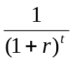 is used to calculate present value in year t, where r is the discount rate. The mitigation ratios in the following sections all reflect the application of a 5% discount rate.

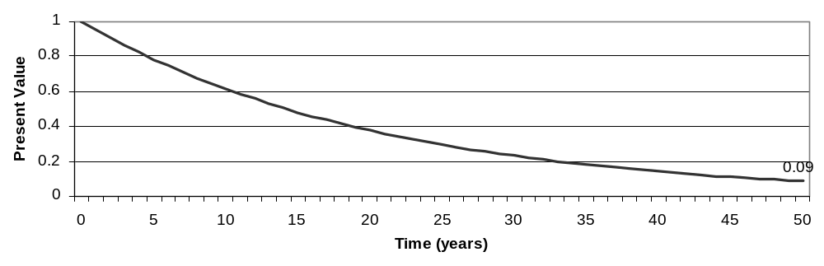
Figure C1. Effect of discounting present value over 50 years.

Appendix D Accounting for Differences in Wetland Location

Wetland location is included in the equation as a scalar of relative change in landscape context of the mitigation site with respect to the impacted wetland. Figure C1 illustrates the basis for considering landscape factors in the assessment of wetland mitigation trades. The wetland at Site A and the wetland at Site B in Figure C1 are shown to be identical in terms of size and shape. For sake of illustration assume that they are also the same type of wetland and are identical in terms of bio-physical characteristics (e.g., soil, vegetation, hydrology). Consider a situation where Site B is a created or restored wetland that is offered as mitigation for the loss of Site A. Since we are assuming that the two sites are identical we are, for now, ignoring the temporal lag and risks associated with mitigation projects and focusing only on landscape factors that might influence the relative value of the two wetlands.

The factors listed above illustrate that the value of Site A, all other things equal, is greater than the value of Site B. They also provide evidence for a rebuttable presumption that a mitigation ratio used to “score” a trade that involves losing wetland area at Site A and gaining wetland area at Site B should be greater than 1:1. However, the existing landscape context of the two sites provides only part of the criteria for taking account of location. For sake of illustration, for example, consider additional evidence that Site B is located where it is more exposed to infestation (or re-infestation) from invasive species, or where it is more vulnerable to disruptions from planned water diversions or anticipated flooding. Consider also the possibility that a new regional 10-year plan designates the area around Site A as “environmentally sensitive—no-growth” and the area around Site B as “industrial—quick permitting.” Any of these conditions would imply that Site A, already more valuable than Site B under current landscape conditions, is likely to be even more valuable in the future. The expected (risk-adjusted) value of each future stream of wetland services from Site A is greater than the expected value of an identical stream of services from Site B because the services from Site B are more likely to be disrupted.

Current Landscape Conditions
Since the wetlands at Site A and Site B are identical they have exactly the same capacity to provide all wetland function. A first approximation of the appropriate mitigation ratio based on site conditions alone, therefore, would be 1:1. Differences in the landscape contexts of Site A and Site B show that they can be expected to provide significantly different services and that the services they provide on a per unit basis are also likely to be different.

For example, consider how differences in landscape context of the two sites would affect their relative value with respect to three specific functions: wildlife habitat, fishery support, and water quality improvements. Even though the two wetland sites are shown to be relatively close to one another (on either side of Route #66) consider the following differences which affect their relative value:

- Site A has more opportunity than Site B to provide wildlife support because it is accessible to wildlife from the upland wildlife refuge area whereas the road blocks the wildlife corridor to Site B.
- Site A has more opportunity to support fish habitat than Site B because it is adjacent to fish habitat whereas Site B is not.
- Site A has more opportunity to improve water quality than Site B because of its proximity to the coast and because it’s longest dimension is parallel to the coast, therefore providing greater "buffering" potential.
- Site A is down-slope of agricultural land uses that generate harmful levels of nutrients that without a wetland at Site A would reach the water body.
- Site B, on the other hand, creates a narrow "buffer" away from the coast and has no significant upslope source of nutrients to filter.
- Even with a source of nutrients, the payoff from filtering nutrients at Site B would be less than at Site A because Site B is adjacent to a polluted and fast-moving section of the water body where harmful effects would be negligible.
- Site A is located where it provides aesthetic and educational opportunities to a nearby residential population whereas Site B is surrounded by industrial sites and private forest lands which limit its amenity values.

These differences indicate how landscape context can affect the relative value of wetlands even if they are identical in terms of site characteristics. It also illustrates the mitigation ratio’s need to reflect location as well as time and risk.

Conclusions about Wetland Location
The above illustration serves to demonstrate three points. First, wetland functional capacity is a necessary but not sufficient condition for wetland value; factors related to the landscape context limit or enhance the expected value of wetlands. Second, information about landscape context provides a logical and defensible basis for comparing relative (non-dollar) wetland values without resorting to complicated and controversial dollar-based valuation methods. Third, mitigation ratios that are intended to take account of differences in the value of wetlands gained and lost through offsite mitigation should take account of differences in wetland location.

Differences in landscape context measured at greater geographic scales, (e.g. different watersheds) can be expected to have similar effects. In fact, the greater the distance between the impacted wetland and the replacement wetland, the greater the potential for broad-scale and systemic differences in landscape conditions that could affect their relative value. This is particularly important when assessing the cumulative impacts of mitigation at the scale of a watershed or a water basin.

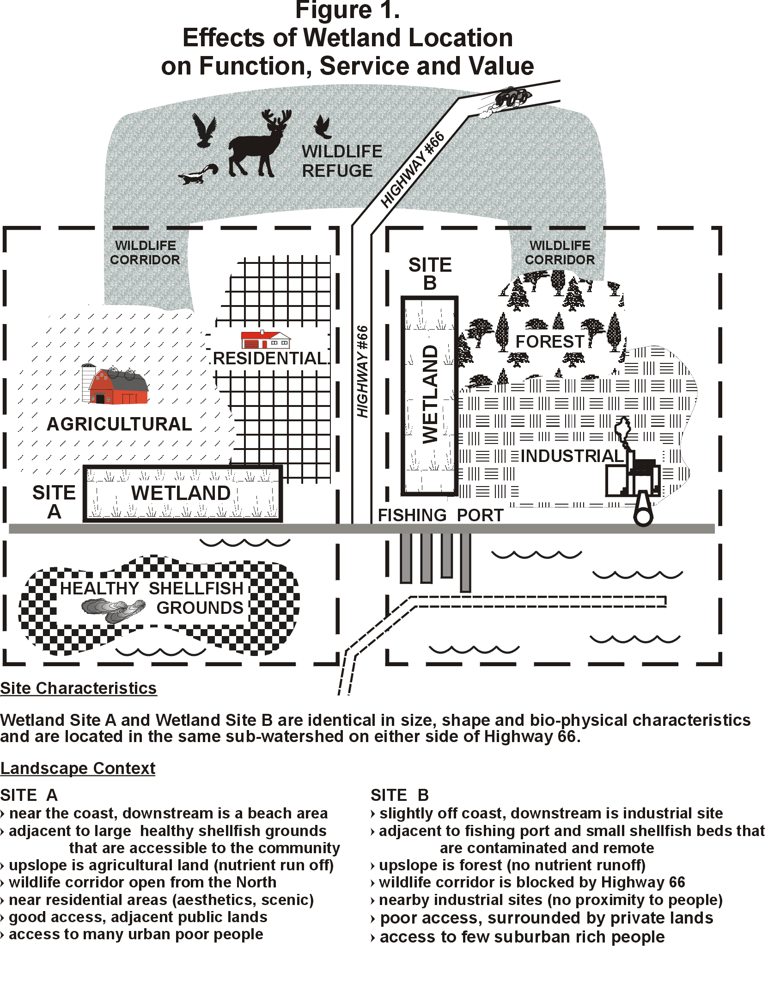

Appendix E Self-mitigation as a Special Case
Statement of the Problem
The MRC, as currently specified, assumes a 100% permanent loss of environmental functions and services at an impact site which is mitigated by way of mitigation project(s) that take place off-site. In the case of the proposed aquaculture, what might be called “self-mitigation” is expected to occur at the impact site as a result of aquaculture operations. This should reduce the amount of off-site mitigation that is required.

General Approach
This situation can most easily be characterized by continuing to specify a 100% loss of environmental functions and services at the impact site, and showing how it is mitigated partially by “self-mitigation” at the impact site and partially by off-site mitigation. The task, then, is merely to show how much off-site mitigation is required to offset the 100% loss of functions and services at the impact site less the losses that will be mitigated as a by-product of on-site activities.

Modification to the MRC
In the current version of the MRC, the numerator represents 100% loss per acre at the impact site and the denominator represents the amount of offsetting gains per acre at the mitigation site. The MRC is simply the ratio of two equations which shows the acres of mitigation required per acre of impact to achieve no net loss of functions and values.

The modified version that takes account of the aquaculture situation involves only modifying the numerator to show that the loss that needs to be mitigated off-site is the 100% loss associated with the project impact less the gains expected from self-mitigation. This involves three simple steps:
- determine the per acre environmental gain from the “self-mitigation” using exactly the same formulation as we have been using for off-site mitigation;
- subtract the resulting per acre gains from “self mitigation” at the impact site from the 100% per acre losses in the numerator of the MRC; and
- leave the denominator of the equation, which reflects the per acre gains associated with the off-site mitigation, unchanged.

Results
The result of modifying the numerator of the MRC in this way to reflect the fact that the net loss per acre at the mitigation site (including “self-mitigation”) is less than 100% will result in each acre of off-site mitigation offsetting more impacted acres. The modified MRC, therefore, will result in a mitigation ratio that takes account of the “self-mitigation” and is smaller than the mitigation ratio that would be required using the basic version of the MRC.

One useful way to characterize the modification to the MRC is as follows:

The current MRC is R = X/Z

The modified MRC is R = (X – Y)/Z

where:
R = The appropriate mitigation ratio expressed as acres of off-site mitigation per acre of impact
X = 100% loss of functions and services per acre at the impact site
Y = the % gain in functions and services per acre from “self-mitigation” at the impact site
Z = the % gain in function and services per acre from off-site mitigation.

The following section provides more details about how to implement this modification to the MRC in order to incorporate time, risk, advanced and delayed mitigation and so on. The most complicated version of the modified MRC equation is provided at the end of the section. This version allows for the possibility that the number of acres of “self-mitigation” provided at the impact site may be less than the number of acres impacted by the aquaculture operation. This could be the case, for example, if docks or site maintenance or shellfish handling facilities occupy some part of the impacted site reducing the size of the aquaculture area that provides self mitigation. This would reduce the overall level of self mitigation provided and increase the amount of offsite mitigation required which would be reflected as an increase in the mitigation ratio.

Step-by-step Development of Self-mitigation Parameters

Simplified Current Version
One of the basic assumptions of the mitigation ratio calculator is that 100% of function is lost at the impact site. In the MRC, the numerator accounts for the lost function. A simplified version of the formula (only using parameters A, B, and C and no accounting for time or risk, or landscape differences or advanced or delayed mitigation) appears like this:

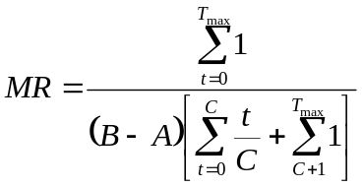where:
(1)
A = level of existing function at the mitigation site,
B = maximum level of function attained at the mitigation site
C = amount of time it takes to achieve full function (B) at the mitigation site.

In equation (1), the numerator reflects the lost function at the impact site by assuming that, without impact, the function would have been 100% (1 in the equation) from time t = 0 to t_{max}. The denominator accounts for function gained at the mitigation site over time. The ratio of lost function to gained function indicates, on a per-acre basis, how much mitigation is necessary to make up for the impact.

Simplified with “self-mitigation”
The formula can be modified in the event that the function lost at the impact site is less than 100% due to ecosystem services provided by the project itself. Assuming that post-impact ecosystem function at the impact site is constant across the entire area (i.e., no impacted acres lose all function), the equation could be adjusted in the following way:

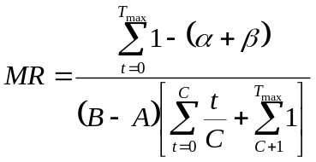where:
(2)
α = level of function remaining after impact
β = level of function associated with the project itself

Incorporating these parameters into the equation reduces the value of the numerator, and therefore reduces the amount of lost function that the mitigation project would need to make up.

(In this version of the equation, parameter α is equivalent to parameter b and parameter β is equivalent to parameter F, as described in “Seagrass Habitat and Shellfish Aquaculture: Evaluating Shellfish Aquaculture Functions/Services to the Environment Within a Wetland (Seagrass) Mitigation Context”)

More Complicated with “self-mitigation”
The formula could also be modified to account for non-homogenous loss of function at the impact site. For example, constructing a shellfish aquaculture facility on 10 acres of seagrass beds could yield total loss of function at 2 acres (due to construction of piers, etc), and partial maintenance or restoration of function at the remaining 8 acres. Adding this refinement, the formula would look like this:

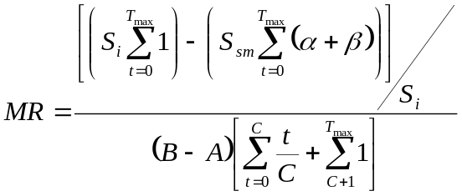where:
(3)
S_{i} = total acreage of the impact site
S_{sm} = area where some function remains (i.e., the area of self-mitigation).

To keep things relatively simple, the modification above divides the impact into two parts. Putting this equation in terms of the shellfish aquaculture example above, the first term in the numerator assumes that all function is lost over the 10 acres of impact. The second term assumes that some function remains and/or is regained over 8 acres of impact. The difference between these terms is then divided by the total acreage of impact to yield the per-acre function that requires mitigation. In other words, if your α + β was 0.2, then the numerator would be [(10 * 1) – (8 * 0.2)]/10 = 0.84. Because this numerator is less than 1, the resulting mitigation ratio would be lower than if 100% of function at the impact site had been lost.

If this incorporation of heterogeneous impacts (different acres of losses and gains at the impact site) were not included, that is, if equation (2) were used, and the same numbers used above applied, the numerator would be 1 – 0.2 = 0.80 (not [(10 * 1) – (8 * 0.2)]/10 = 0.84) which would lead to an inappropriately low mitigation ratio because the numerator would be too small. Adding this spatial refinement to the formula may not always be useful, but does not complicate things very much and allows the user to approximate the actual gains and losses at the impact site in terms of quantity (acres) as well as quality (gains and losses per acre) and capture mitigation tradeoffs more closely.

More Complicated by adding time
If it takes a certain period of time for the aquaculture project to achieve its full ecosystem function, the equation would look like this:
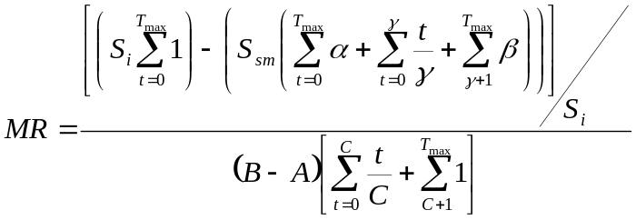
where:
γ = the amount of time it takes to attain function β.
(4)

Most Complicated by discounting and adding risk, landscape factors, etc.
Finally, if the discount rate, time, risk and landscape context are factored into equation (4), it would appear as follows:
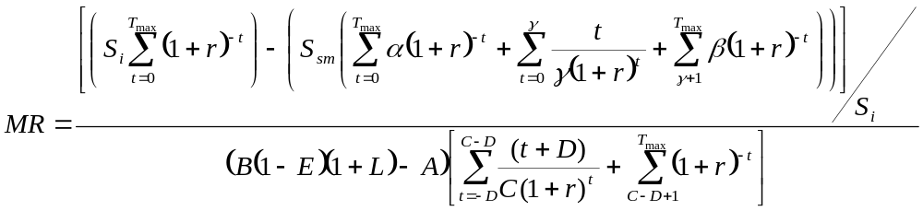
(5)

where:
D = Number of years before destruction of the original wetland that the mitigation project begins to generate mitigation values
E = Risk that the mitigation project will fail and provide none of the anticipated benefits
L = Percent difference in expected wetland values based on differences in landscape context of the mitigation site and impacted wetland
r = discount rate

These percentages are taken directly from Brown and Lant (1999) and sum to 101%, presumably because of rounding error.
For more information on how landscape context should factor in to decision making in wetland mitigation, see Appendix D.

